**Human Computer Interaction**

*Supervised by Dr. Ann Nossair*

**Final Project Assessment Report**

TED Application

Name: Yousef Mohamed Hussien

**TED App Interface Assessment**

According to statistics done by showing and observing the opinion of group of people on the new Application UI Design compared to the already existing one.

1. **Visibility:**

- All functions and pages of the application are clear and obvious.

- User can know where he/she is by a colored symbol of the current page.

- Video Titles are written on the thumbnail of the video which can be hard to read and distracting.

|  |  |  |  |  |  |  |  |  |  |
| --- | --- | --- | --- | --- | --- | --- | --- | --- | --- |
| 1 | 2 | 3 | 4 | 5 | 6 | 7 | 8 | 9 | 10 |
|  |  |  |  |  |  |  |  |  |  |

Strongly Strongly

Disagree Agree

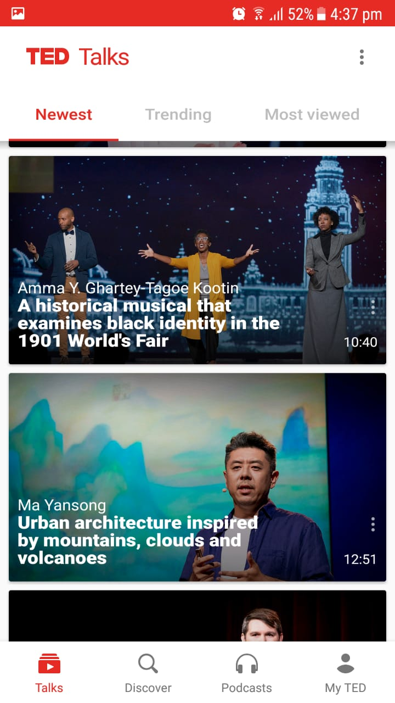

Main menu contains all application pages

The red colored icon is the current page

Hard to read text on video thumbnail image

Submenu

Logo and Settings

1. **Consistency:**

- Consistent app theme in all pages equivalent to Ted website and logo.

- Fixed placement of the menu at the bottom in all screens.

|  |  |  |  |  |  |  |  |  |  |
| --- | --- | --- | --- | --- | --- | --- | --- | --- | --- |
| 1 | 2 | 3 | 4 | 5 | 6 | 7 | 8 | 9 | 10 |
|  |  |  |  |  |  |  |  |  |  |

Strongly Strongly

Disagree Agree

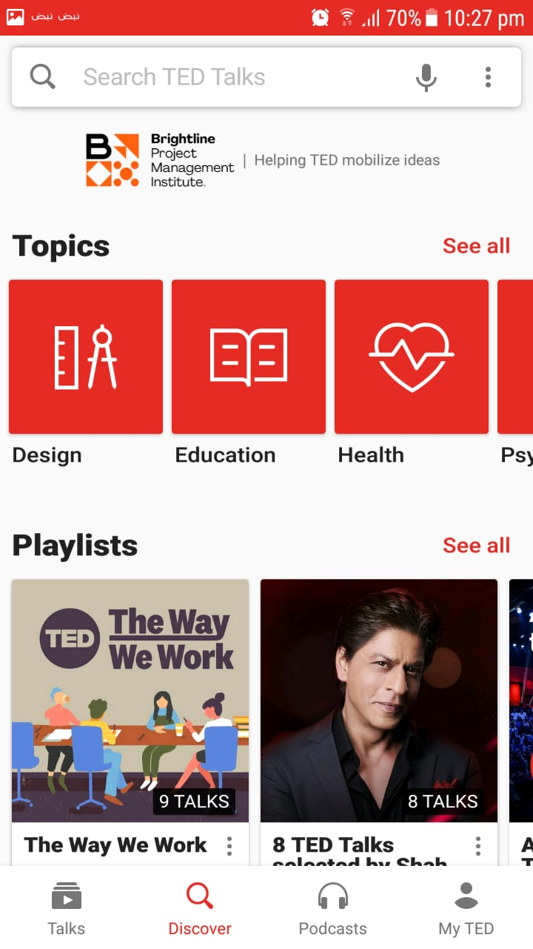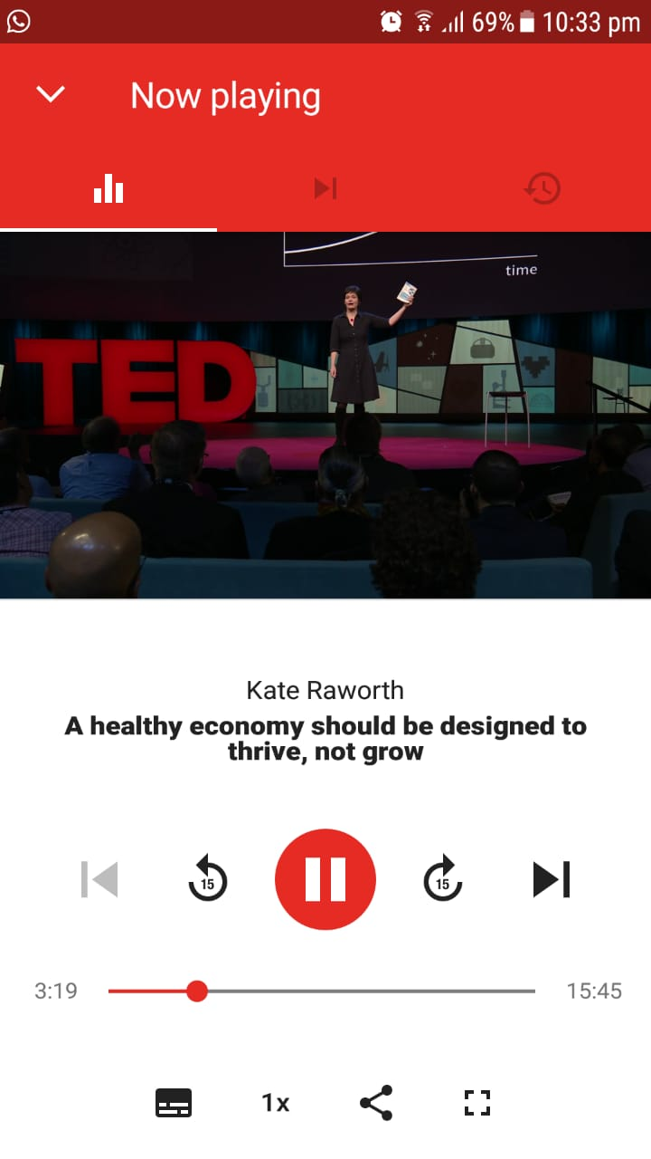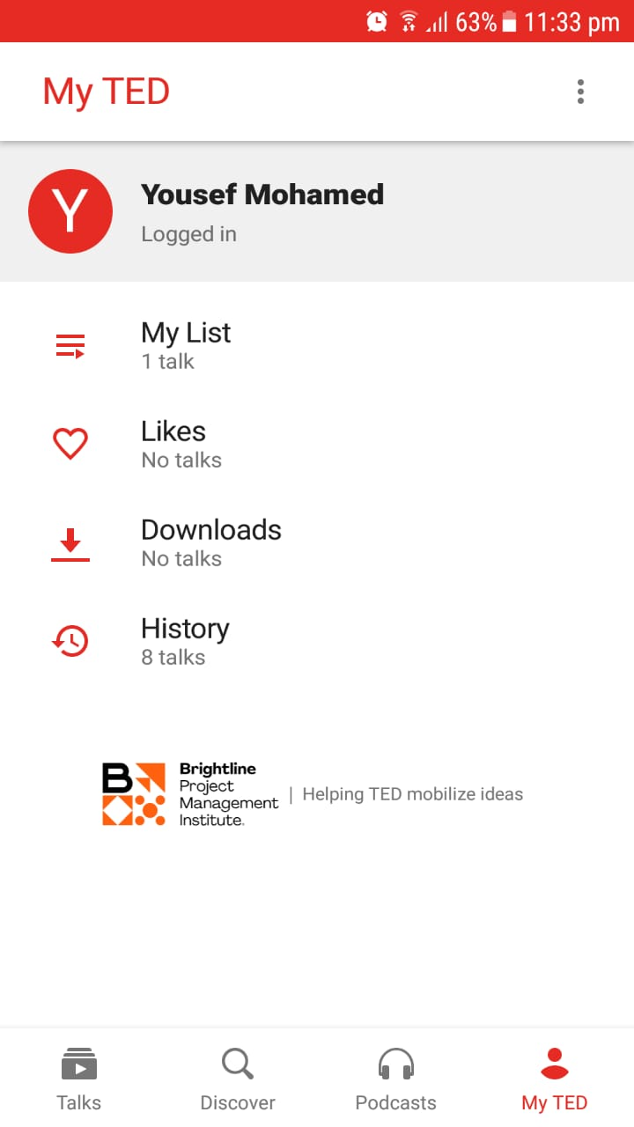

Consistent red theme with a fixed navigation bar at the bottom in the main pages.

1. **Familiarity**:

- Using familiar words and phrases as ‘Trending’, ‘Talks’, ‘Discover’.

- Using known symbols as for settings, like, share, arrows and others.

- Ability to refresh the page by dragging down gesture.

- No left/right swipes between tabs, you should use the menu.

|  |  |  |  |  |  |  |  |  |  |
| --- | --- | --- | --- | --- | --- | --- | --- | --- | --- |
| 1 | 2 | 3 | 4 | 5 | 6 | 7 | 8 | 9 | 10 |
|  |  |  |  |  |  |  |  |  |  |

Strongly Strongly

Disagree Agree

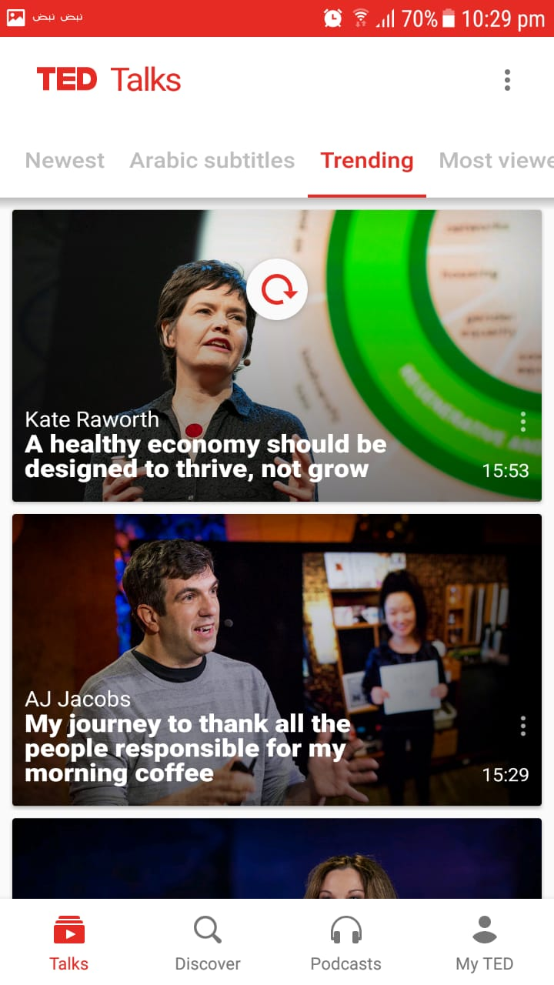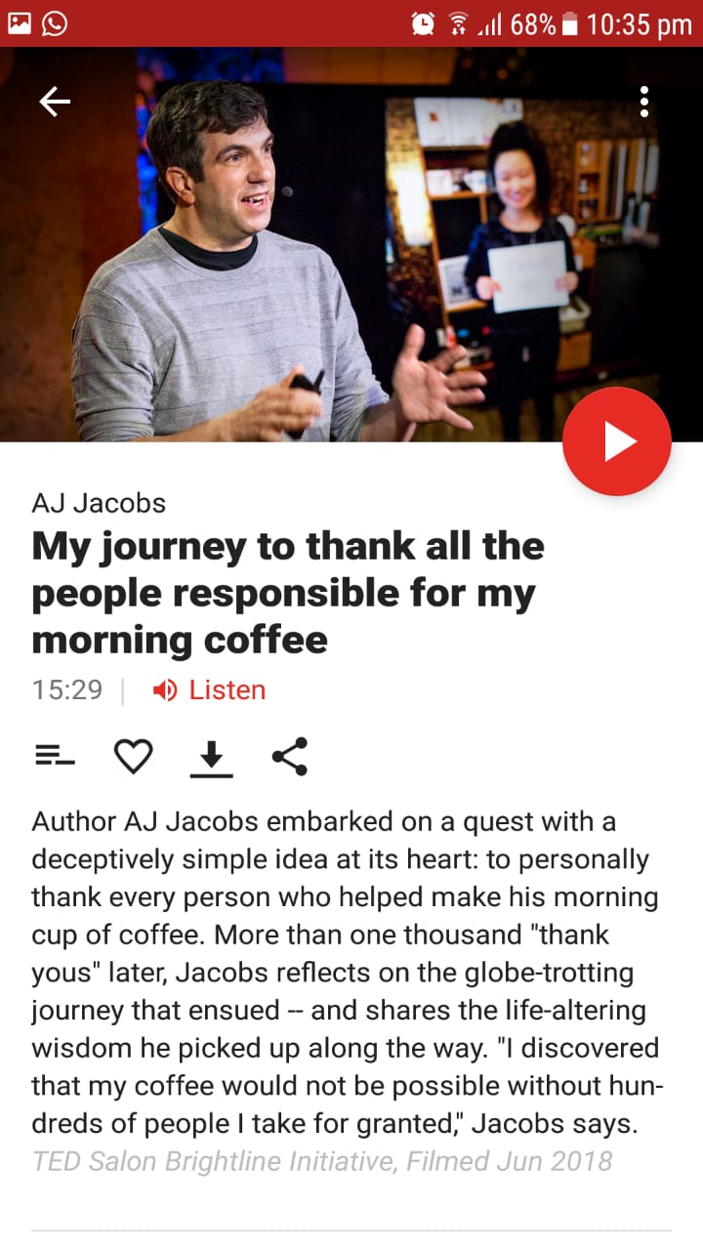

1. **Affordance**:

- Clear and common icons used as for play/pause, next/previous buttons, search, microphone, headphone symbols and the character icon that represents the user account.

|  |  |  |  |  |  |  |  |  |  |
| --- | --- | --- | --- | --- | --- | --- | --- | --- | --- |
| 1 | 2 | 3 | 4 | 5 | 6 | 7 | 8 | 9 | 10 |
|  |  |  |  |  |  |  |  |  |  |

Strongly Strongly

Disagree Agree



1. **Navigation**:

- Fixed navigation menu at the bottom of the screen to walkthrough all the functions of the application

- An unnecessary page (2 steps) to open a video, these 2 pages is better to be one page.

|  |  |  |  |  |  |  |  |  |  |
| --- | --- | --- | --- | --- | --- | --- | --- | --- | --- |
| 1 | 2 | 3 | 4 | 5 | 6 | 7 | 8 | 9 | 10 |
|  |  |  |  |  |  |  |  |  |  |

Strongly Strongly

Disagree Agree

Fixed Navigation bar

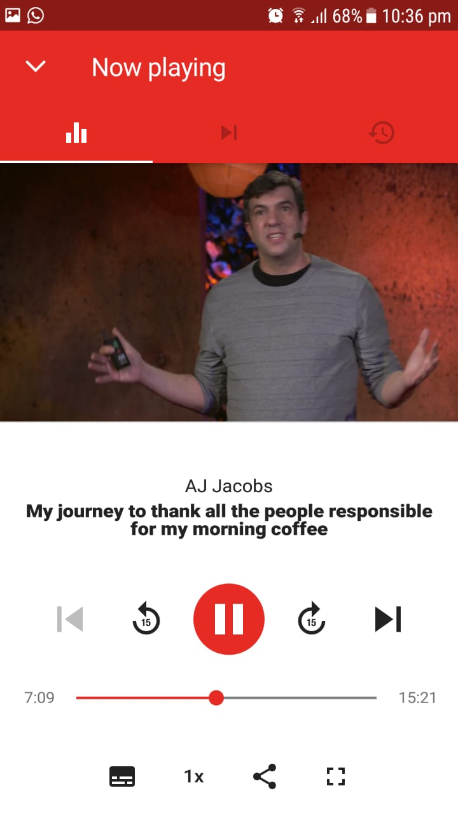

Step3:

See the video player in another page

Step1:

Choose the Talk

Step2:

Click Play Button

1. **Control**:

- User can choose the subtitle language from more than 100 languages.

- Dual subtitle option to help users learn a new language while watching.

- Does not force you to log in or create an account at the beginning, but gives you the chance to experience and use the application.

- No adjusting the quality of the video option.

- No Filter option in search, which makes it hard to find what user want.

- Does not have the option to create your own playlists, but gives you one list only named as ‘My List’.

- No comment section on videos to let users know others opinions.

- Does not collect user interests at the beginning, or even does not view the videos related to user watch or search history, so user usually see uninteresting video topics and all users see the same videos suggestions.

|  |  |  |  |  |  |  |  |  |  |
| --- | --- | --- | --- | --- | --- | --- | --- | --- | --- |
| 1 | 2 | 3 | 4 | 5 | 6 | 7 | 8 | 9 | 10 |
|  |  |  |  |  |  |  |  |  |  |

Strongly Strongly

Disagree Agree

Many sub languages

Dual sub option

No Set Quality Option

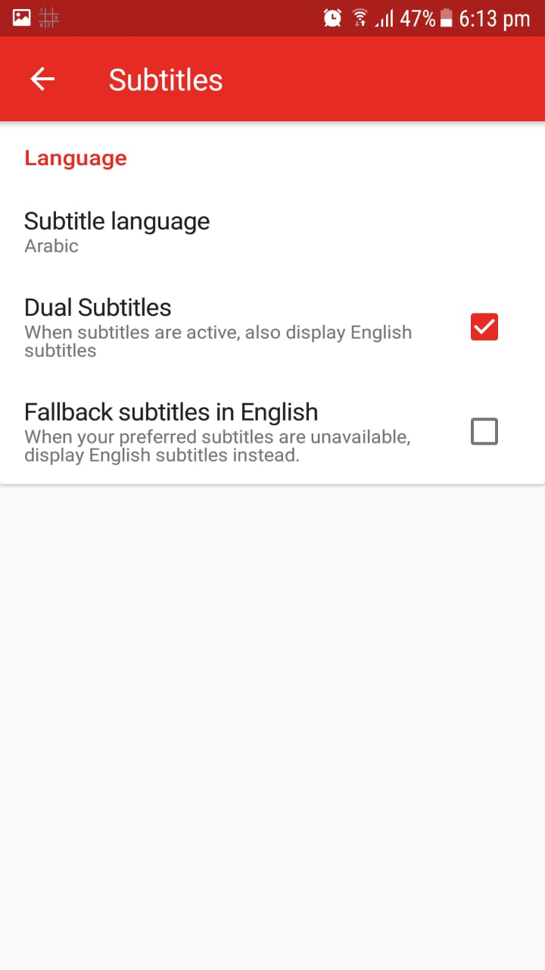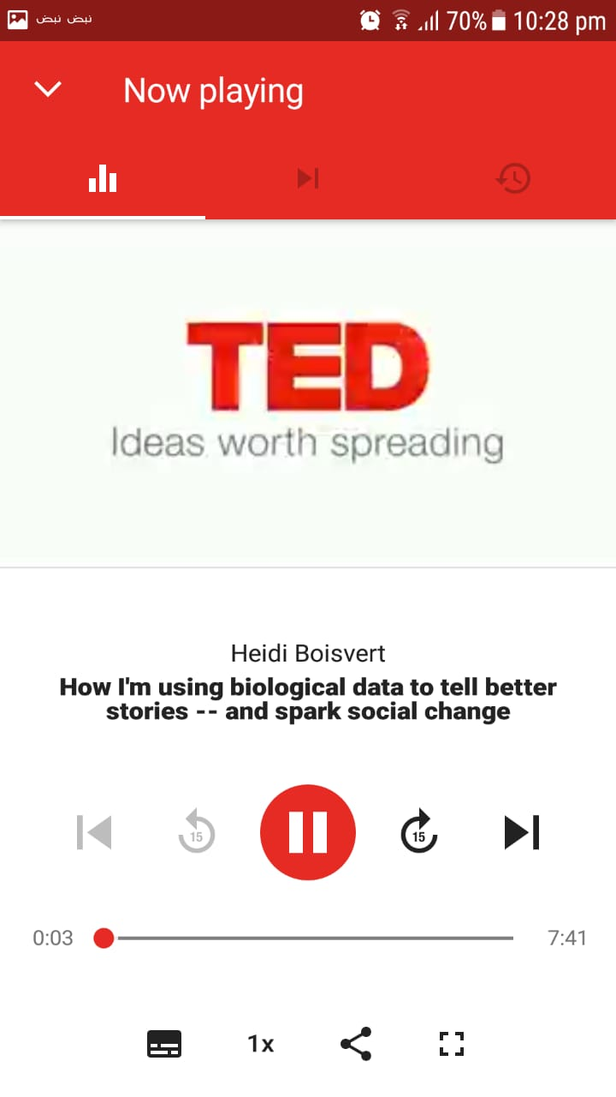

One user playlist only.

No Search Filter Option

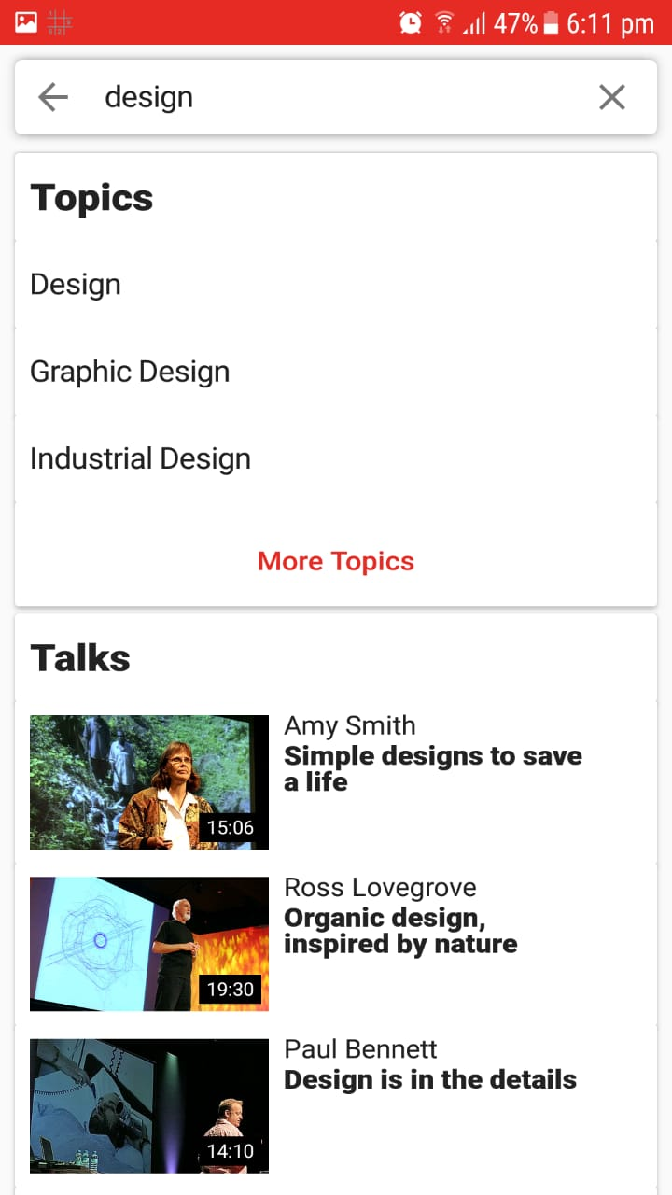

1. **Feedback**:

- Have a Loading animation when loading a video or logging in.

- Viewing a message when adding the video to the list or to the likes

or when it finishes downloading.

- Viewing an alert message when entering wrong email or password.

- Does not give a mark or a sign on watched videos.

- No Alert message when there is no internet connection.

- Does not view the number of views and likes on each video.

|  |  |  |  |  |  |  |  |  |  |
| --- | --- | --- | --- | --- | --- | --- | --- | --- | --- |
| 1 | 2 | 3 | 4 | 5 | 6 | 7 | 8 | 9 | 10 |
|  |  |  |  |  |  |  |  |  |  |

Strongly Strongly

Disagree Agree

No Views/Likes Number

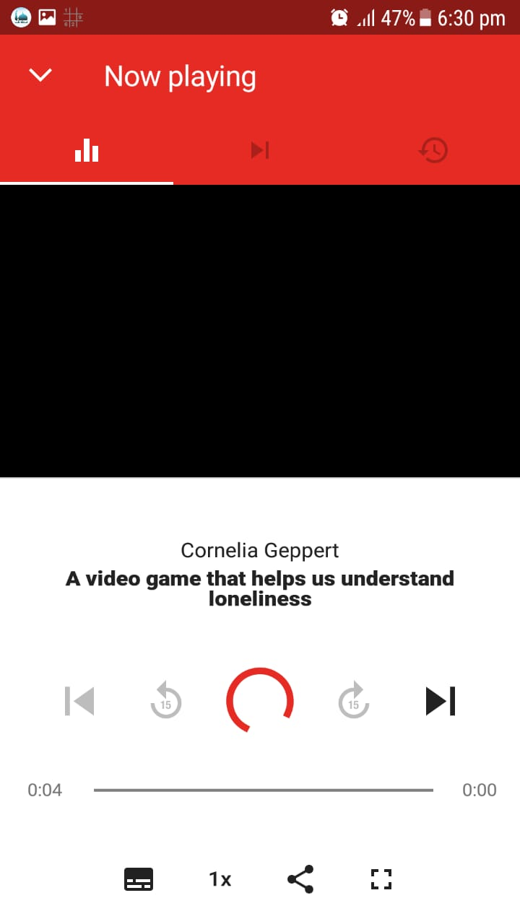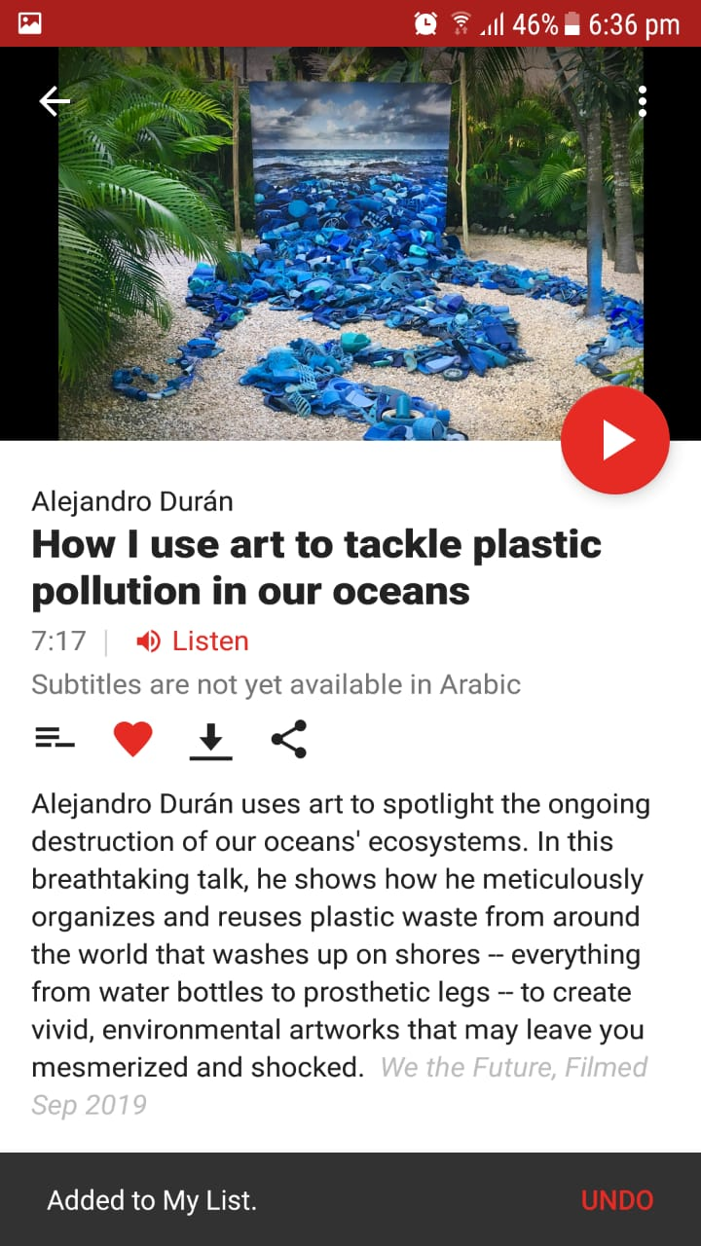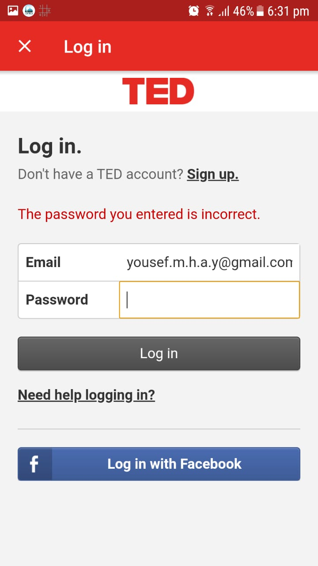

1. **Recovery**:

- Has a return back to the previous page arrow.

- Provide an Undo option when adding a video to ‘My List’ or ‘Likes’.

- The application automatically backup user’s data and sync it with the account to be able to use it on multiple devices.

|  |  |  |  |  |  |  |  |  |  |
| --- | --- | --- | --- | --- | --- | --- | --- | --- | --- |
| 1 | 2 | 3 | 4 | 5 | 6 | 7 | 8 | 9 | 10 |
|  |  |  |  |  |  |  |  |  |  |

Strongly Strongly

Disagree Agree



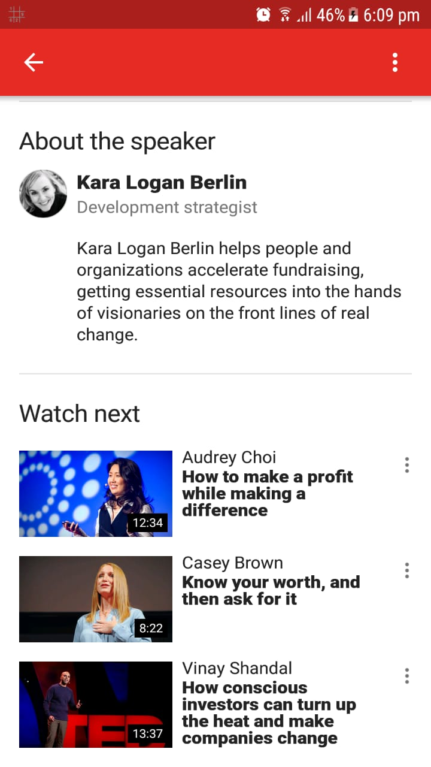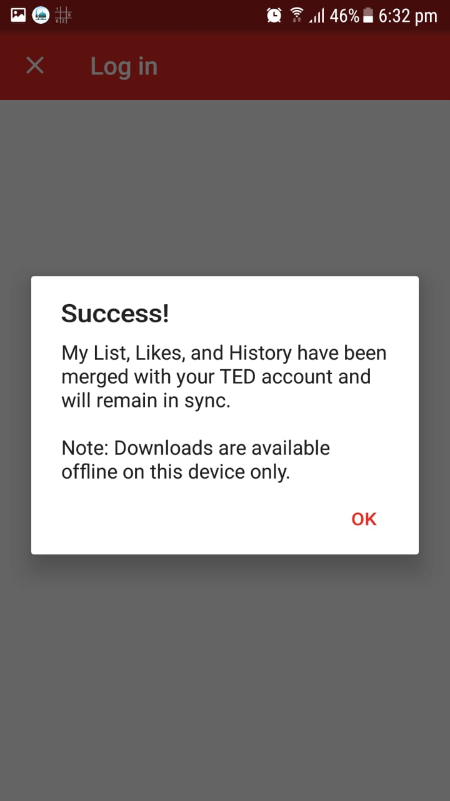

1. **Constraint**:

- Prevent log in when typing wrong email or password.

- Gives a confirmation message before logging out.

- Video options as like, share, download are very small and close to each other, which could cause the user to perform a wrong action.

|  |  |  |  |  |  |  |  |  |  |
| --- | --- | --- | --- | --- | --- | --- | --- | --- | --- |
| 1 | 2 | 3 | 4 | 5 | 6 | 7 | 8 | 9 | 10 |
|  |  |  |  |  |  |  |  |  |  |

Strongly Strongly

Disagree Agree

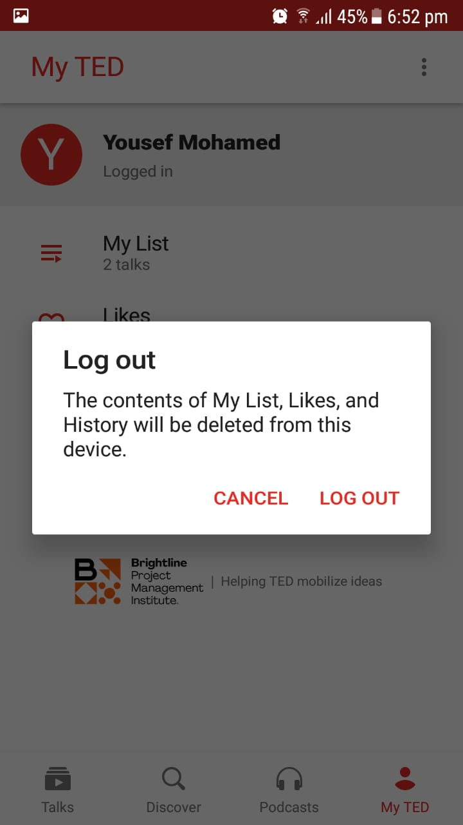

1. **Flexibility**:

- Adding a specified section, for experienced user when they add their subtitle language of the videos, which has videos support their language.

- No Dark mode theme that is comfortable while watching at night.

- Contains Topic Categories and Default Playlists to choose from them.

- The application made in many languages (English by default).

- Add the option to know the upcoming events near the user.

- In Settings, Limiting data usage option is disabled by default and background Playback on by default, which may cause a big cellular data loss to the users.

|  |  |  |  |  |  |  |  |  |  |
| --- | --- | --- | --- | --- | --- | --- | --- | --- | --- |
| 1 | 2 | 3 | 4 | 5 | 6 | 7 | 8 | 9 | 10 |
|  |  |  |  |  |  |  |  |  |  |

Strongly Strongly

Disagree Agree



Experienced User

New User

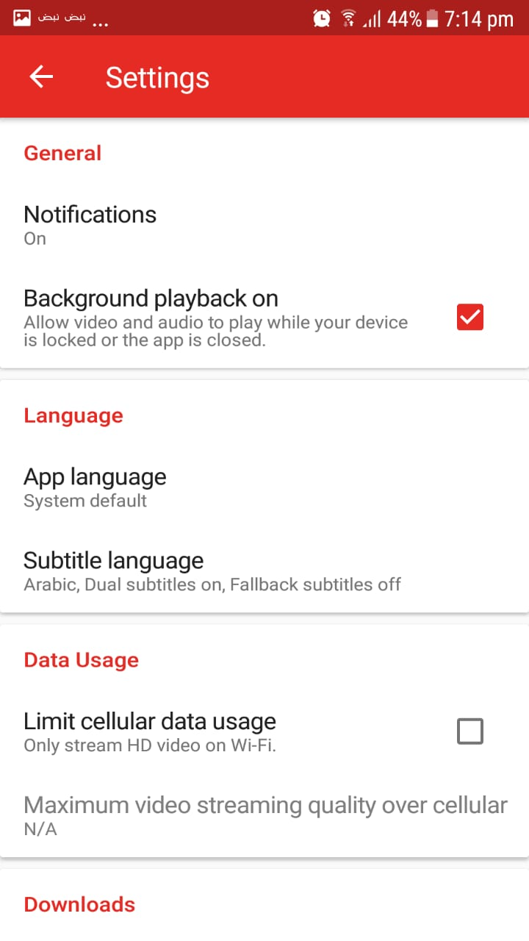

1. **Style**:

- Uses a Professional red theme design across all the app and equivalent to Ted Website and Ted Logo.

- Uses interesting icons and symbols as in ‘Discover Topics’.

- The login form style improperly changes when entering incorrect information.

|  |  |  |  |  |  |  |  |  |  |
| --- | --- | --- | --- | --- | --- | --- | --- | --- | --- |
| 1 | 2 | 3 | 4 | 5 | 6 | 7 | 8 | 9 | 10 |
|  |  |  |  |  |  |  |  |  |  |

Strongly Strongly

Disagree Agree

After entering wrong password

Before entering wrong password

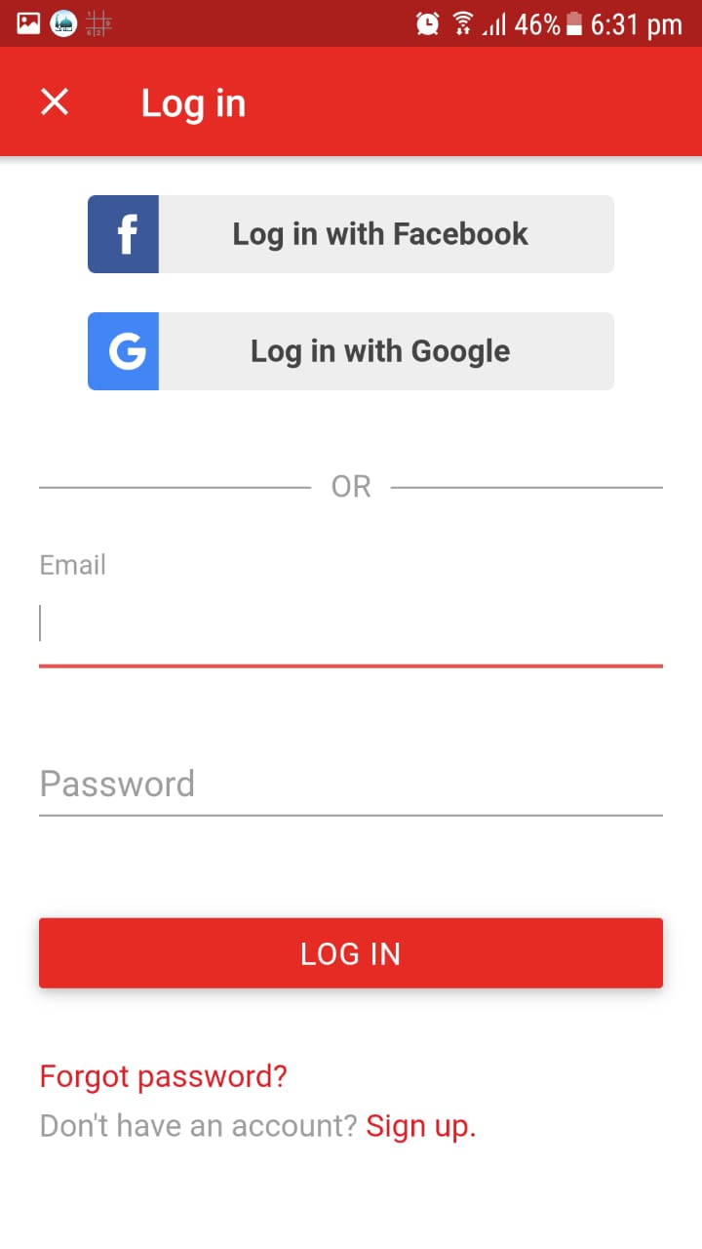

1. **Conviviality**:

- No frustrating popup ads.

- No fixed ads on screen.

- One short 5 seconds ad of the sponsor before the video.

|  |  |  |  |  |  |  |  |  |  |
| --- | --- | --- | --- | --- | --- | --- | --- | --- | --- |
| 1 | 2 | 3 | 4 | 5 | 6 | 7 | 8 | 9 | 10 |
|  |  |  |  |  |  |  |  |  |  |

Strongly Strongly

Disagree Agree

**Analysis Phase**

**Observation:**

The Users usually when they open the app, they look for some interesting video talks that they want to watch to learn. The age of Users using the application varies between 18 and 30, but mainly anyone have the passion to learn is our targeted user, and anyone can benefit from this application content.

Most of people who use TED application they use it at home or at their office and may be while in transportation at different times of day. The User like to see the videos related to the topics he/she is interested. When the user wants to see a specific video he/she tends to search for it, so he/she starts to look for the search icon at the top right corner.

**Questionnaire:**

* The Questions and its Statistics:

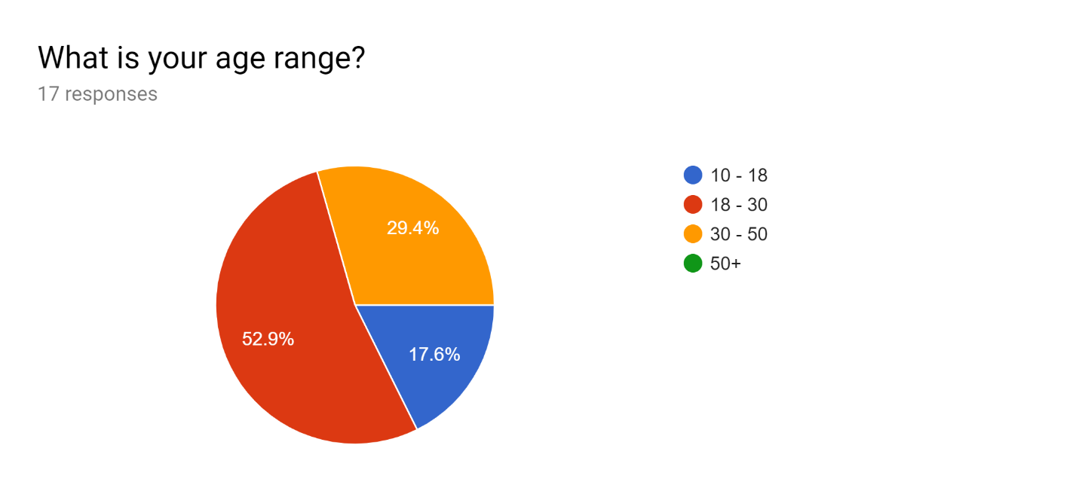

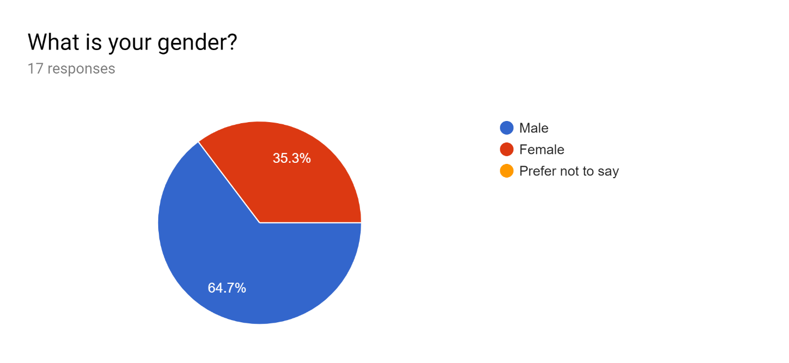

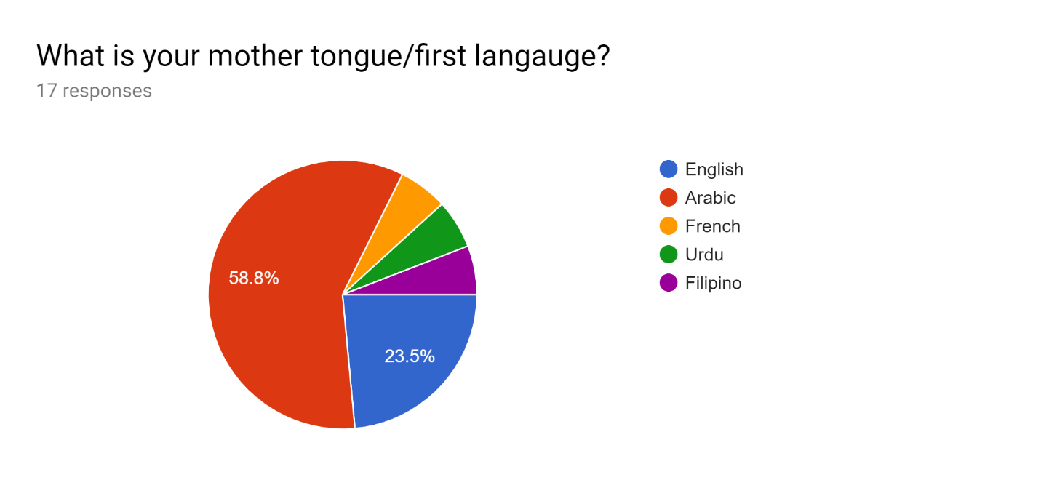

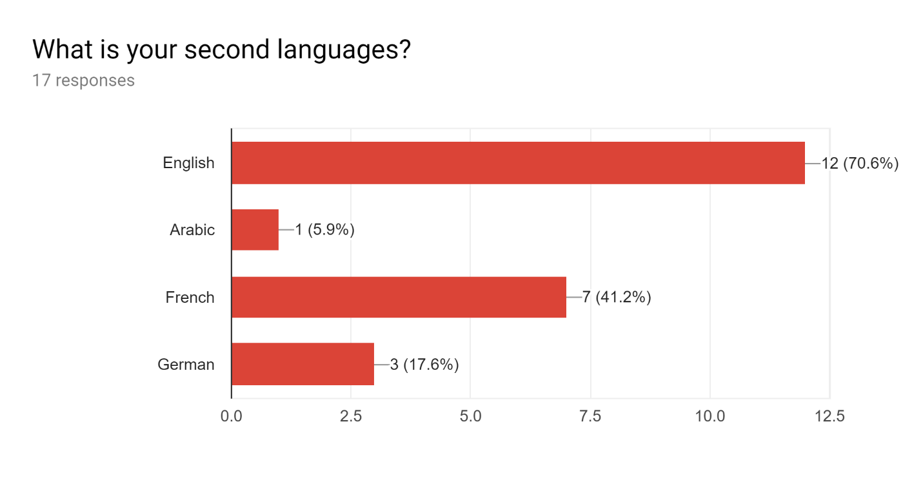

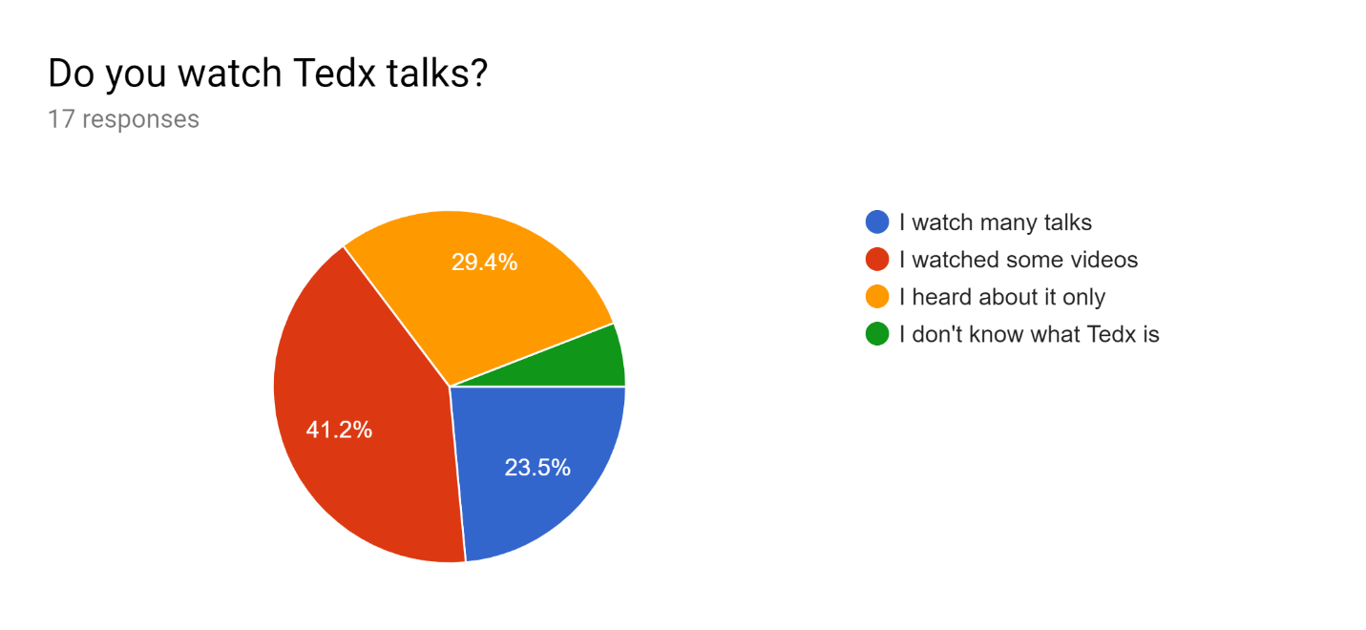

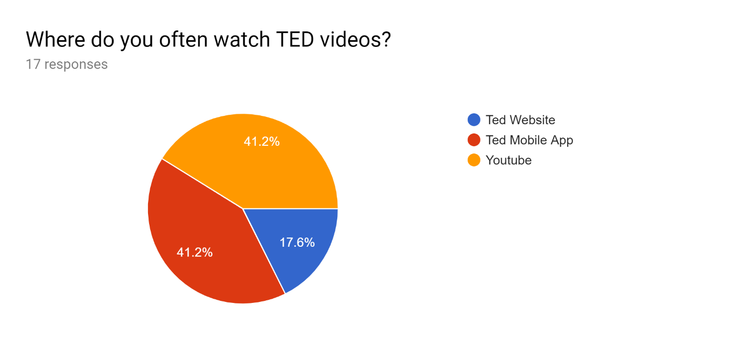

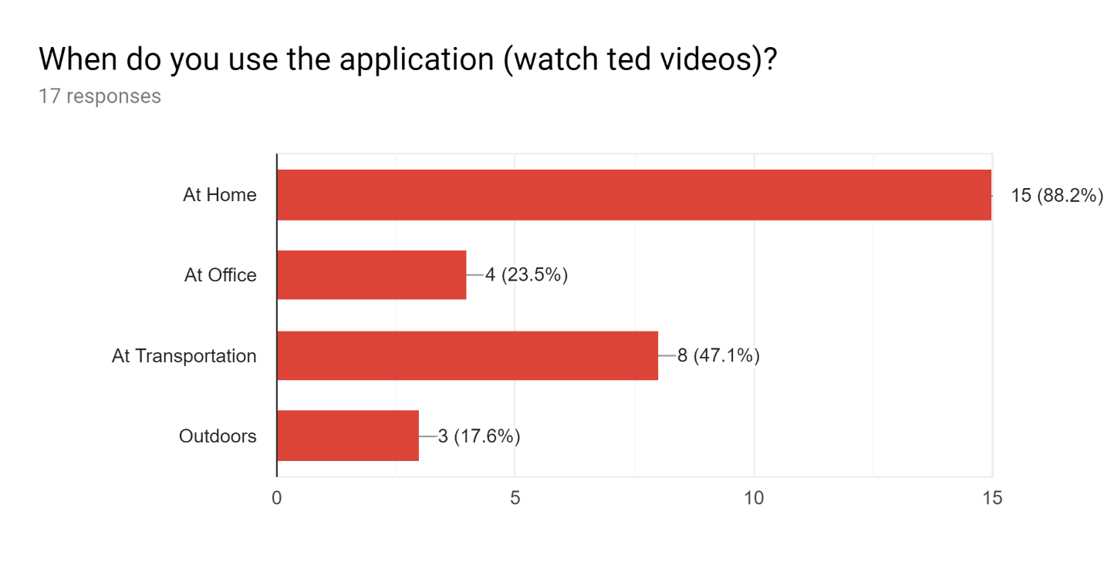

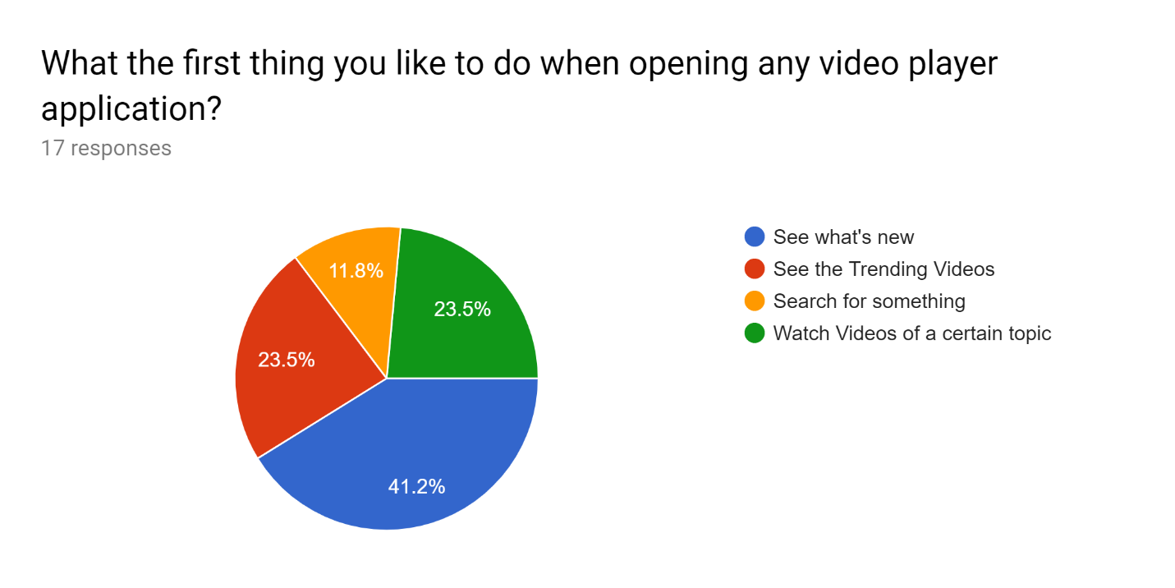

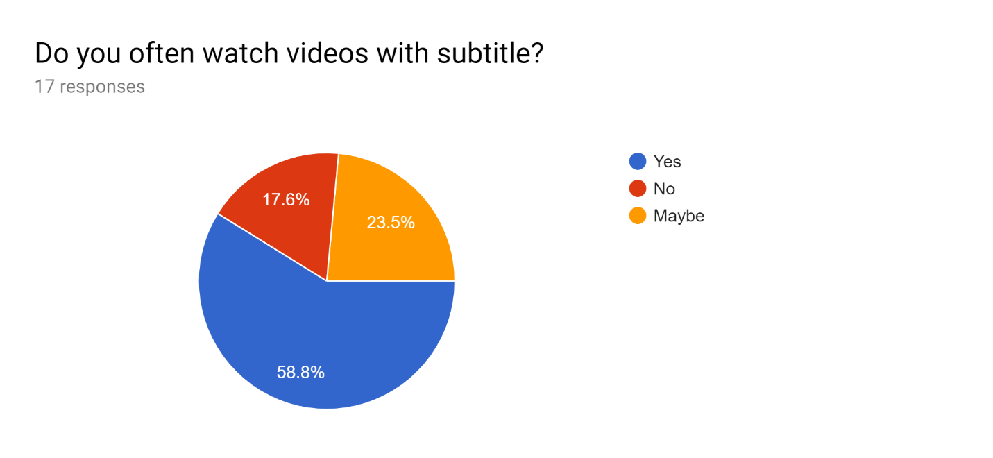

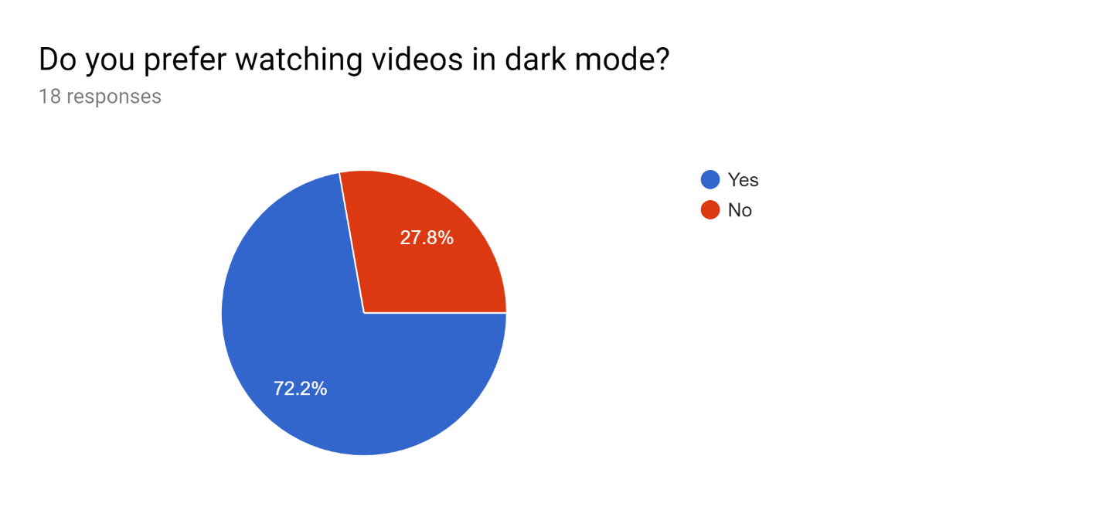

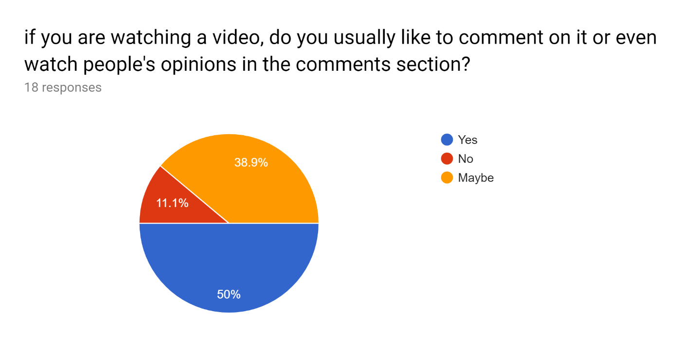

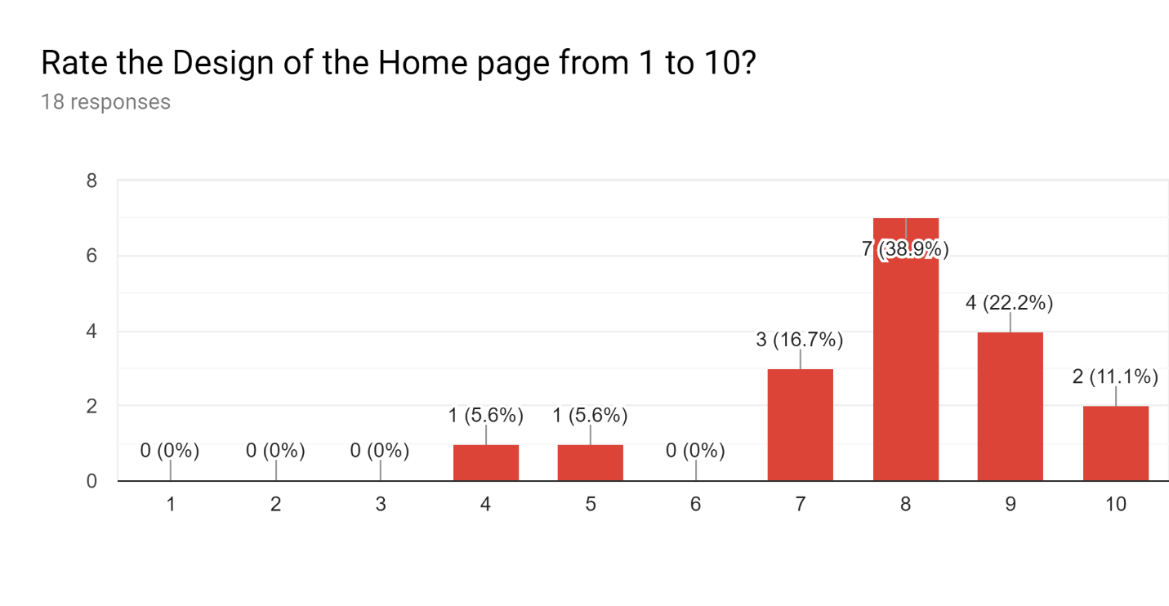

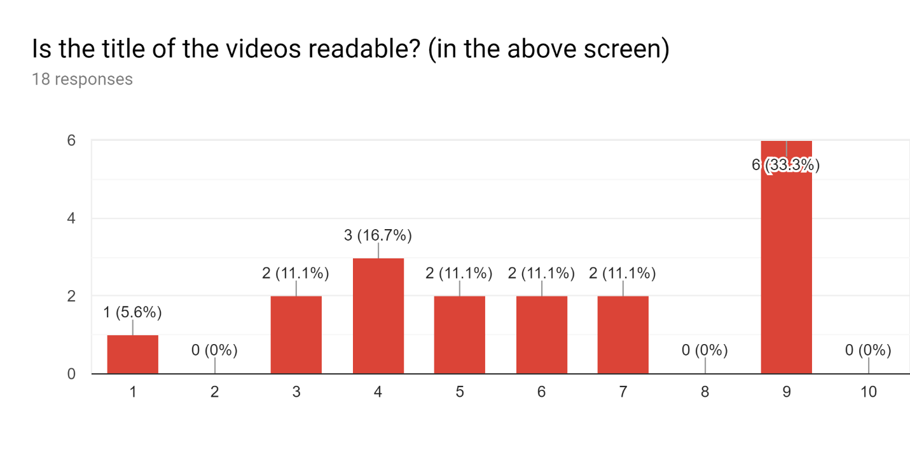

What option do you wish to be added in app? /What should the app improve?

Some answers:

- A sign on watched videos

- Changing video quality

- Showing the number of views on video

- Upcoming events near me

- Adding Filter option in search

- Solve Downloading bugs

**PACT Analysis:**

|  |  |  |
| --- | --- | --- |
| **PACT** | **Characteristics** | **User Interface Consideration** |
| **People** | - Age between 15 and 55  - Both male and female  - May have minimal education qualification  - Motivated to use the app  - Could have poor eyesight  - All languages but know English language at least  - Could have no experience  - All Cultures  - Use app Frequently | - Use Simple Interface Design  - Use familiar, clear icons  - Adjust the spacing between icons to avoid making mistakes  - The default language is English  - Easy, common words and phrases  - Use appropriate text font size  - Color contrast between the text and the background |
| **Context** | - At home, office or transportation  - Different weather conditions  - Using a smartphone, tablet, TV  - Poor internet connection or on cellular data connection  - At any time (Day and Night) | - Can be used offline  - Set the quality of video option  - Have Dark mode/Dark theme  - Alert when no internet connection  - Responsive Application  - Hide Security information |
| **Task** | - Watch Ted talks to learn  - Browse Topics or speakers  - Regular (weekly) as average  - Well-defined  - Individual or in groups | - Make a task done fast and easy  - A task is done in minimal steps  - View confirmation messages, alerts and notifications on actions  - Ability to recover any error |

**Scenario 1:**

A man after working in his office, at his break time, he decided to watch a video talk on TED application. He opened the app to see the Watch page on the tab newest, he scrolled down to choose from the newest videos, but he did not find what he want so he went to the tab trending by swiping left, then he saw a video thumbnail and read the title which attracted him, so he tapped on the video thumbnail to see the video opening at the top part of the screen under it the title and the description

After watching the video, he decided to give a like to it and add it to his list and also follow the speaker to watch more from him.

**Scenario 2:**

A woman sitting in her house, opening TED application as usual to watch a playlist that contains videos on design (the topic she is interested in). The Watch page appears at first, she goes to Discover page by the navigation bar at the bottom, the application shows her some playlists she might like but she wanted a specific topic, so she tapped on the third tap at submenu at the top of the screen, then she chooses the design topic rapidly when she see the design icon, after that she opens the playlist she likes and watches it.

**Scenario 3:**

A young man with his friends decided to go an event by Tedx, so he opened the app, choose the Events symbol at the bottom, then he looks at the map and taps on his country on it, The application view below the map all the upcoming events with all their information and if they are available or not.

**Scenario 4:**

A young man is opening TED application for the first time, a welcome screen appears then the application asks him to choose from some topics what he is interested in, he chooses some topics and confirms, the watch page appears having some videos that he might like.

A notification appears advices him to sign up to save his activity, he goes to My ted, tap on the login button at the top a login form appears he clicks on sign in with Google to sign up fast then a message pops up confirming that the log in successfully done.

**Design Phase**

**Sitemap:** *The New Design*

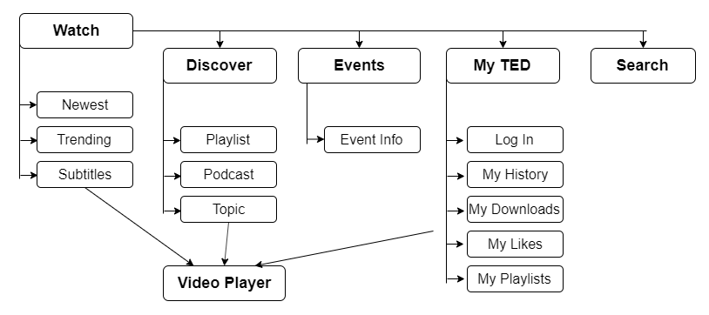

**Low fidelity:**

1. **Watch Page has 3 tabs (Newest, Trending, Subtitle) similar in design.**

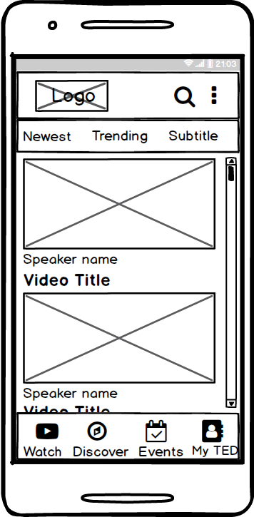

1. **Discover Page has 3 tabs ( Playlist, Podcast, Topics).**

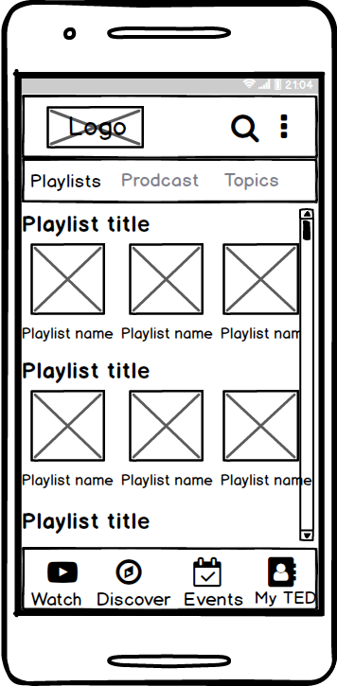 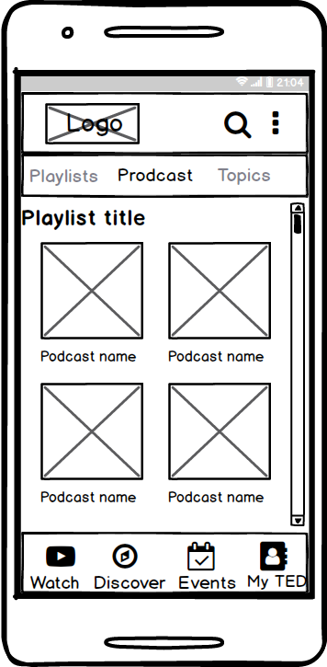

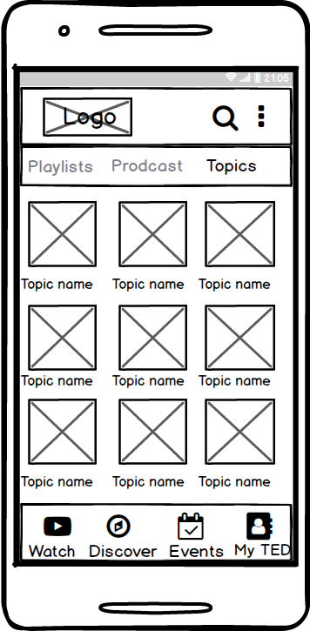

1. **Events Page**

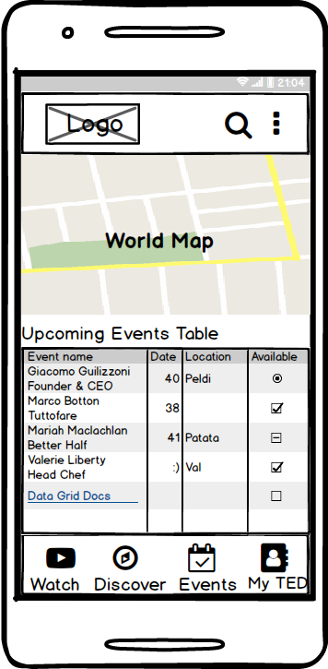

1. **My TED Page and the Log In Page**

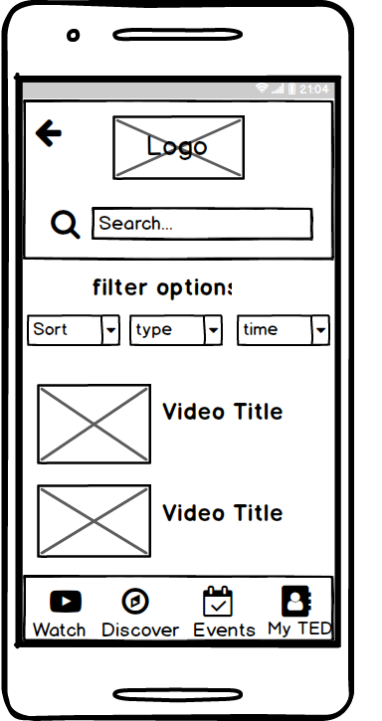

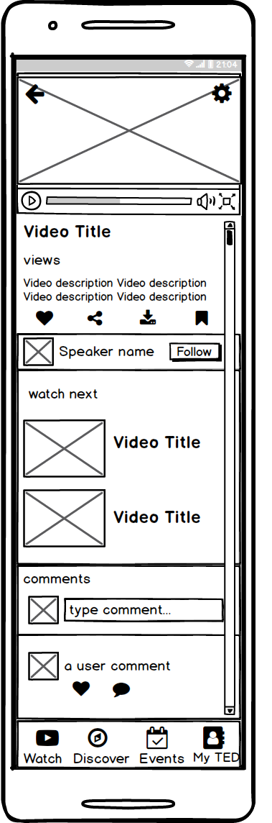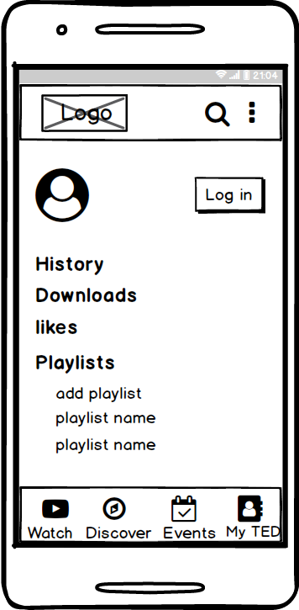

1. **The Video Player Page 🡪**

**High fidelity:**

1. **Watch Page has 3 tabs (Newest, Trending, Subtitle)**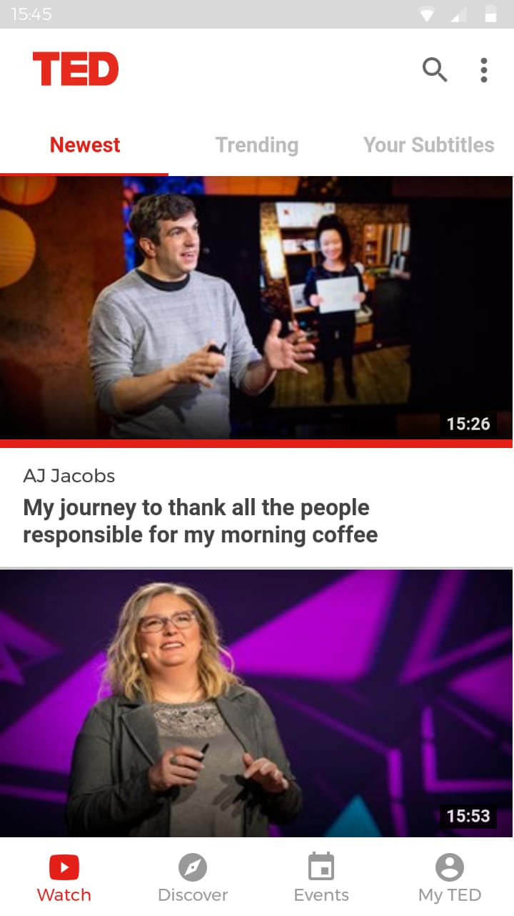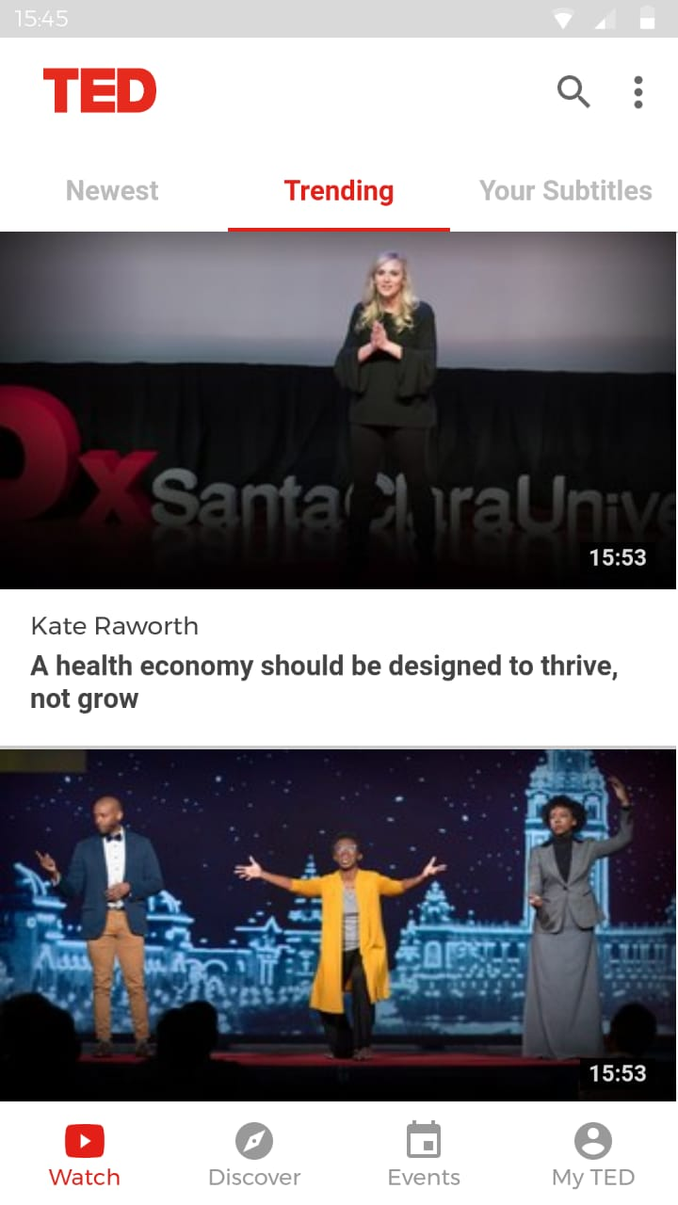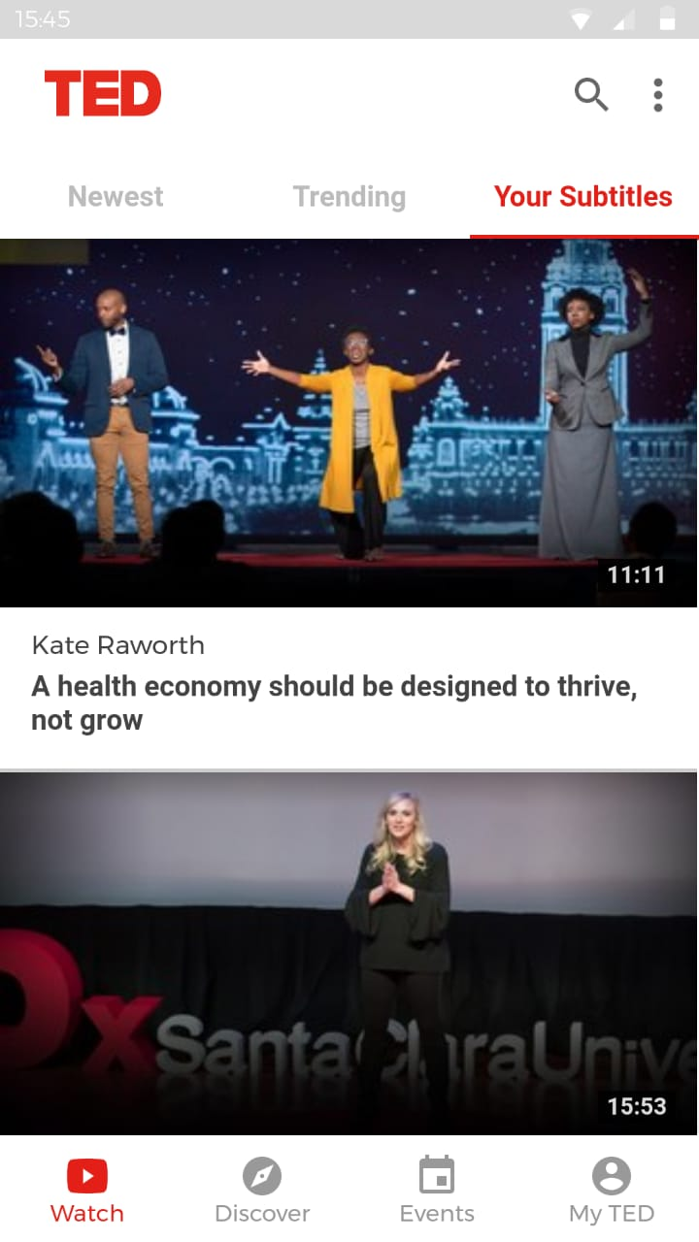

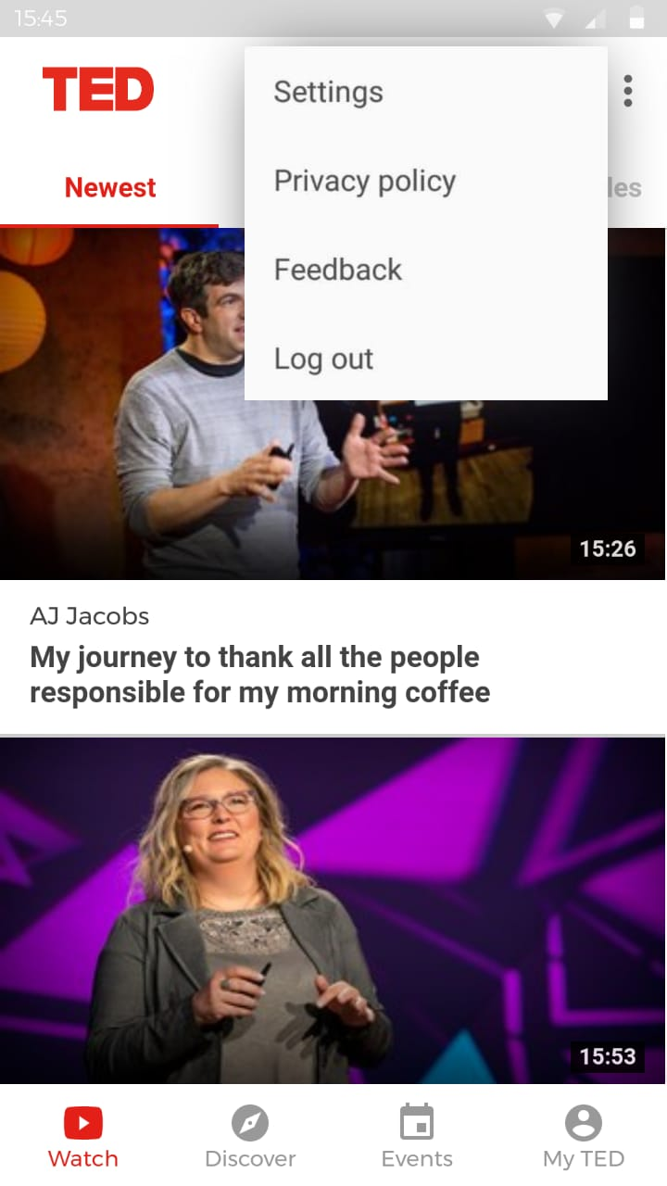

1. **Discover Page has 3 tabs (Playlist, Podcast, Topics).**

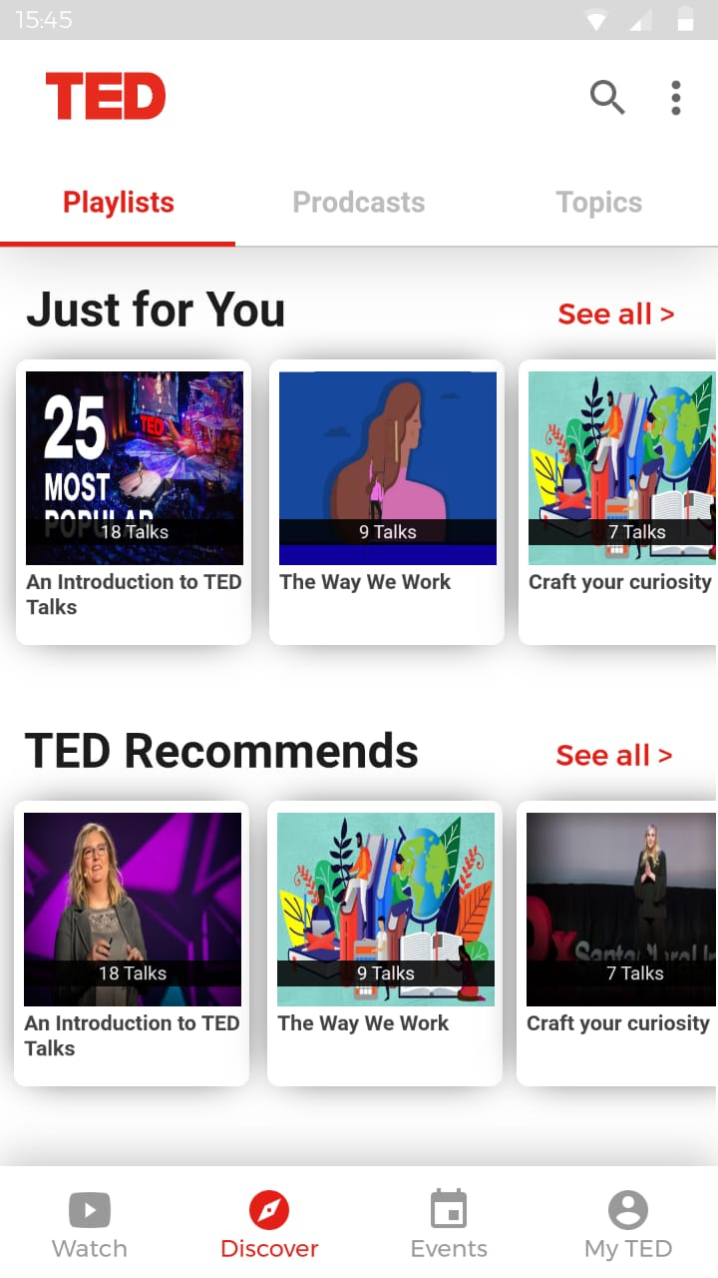

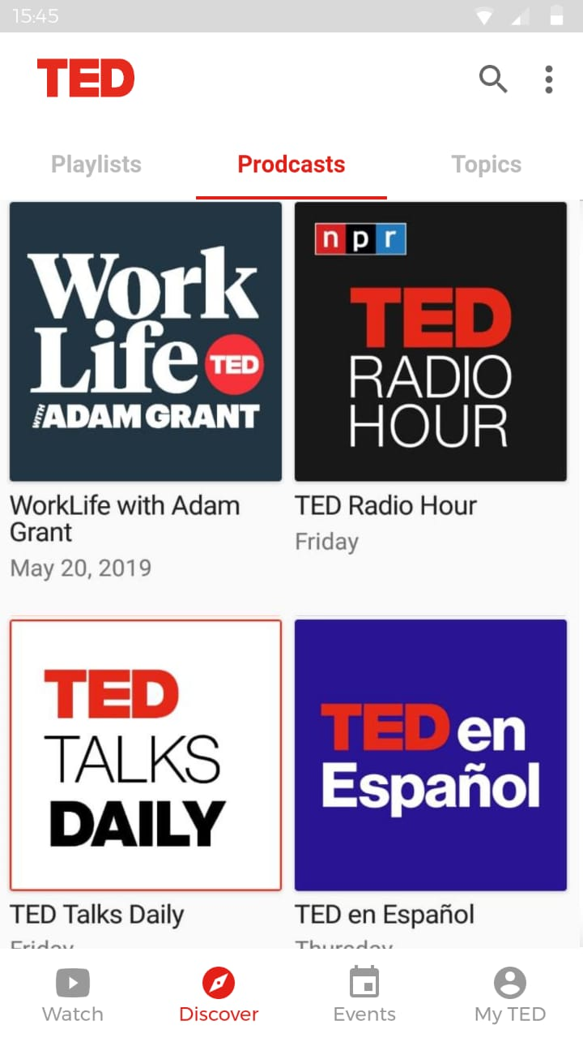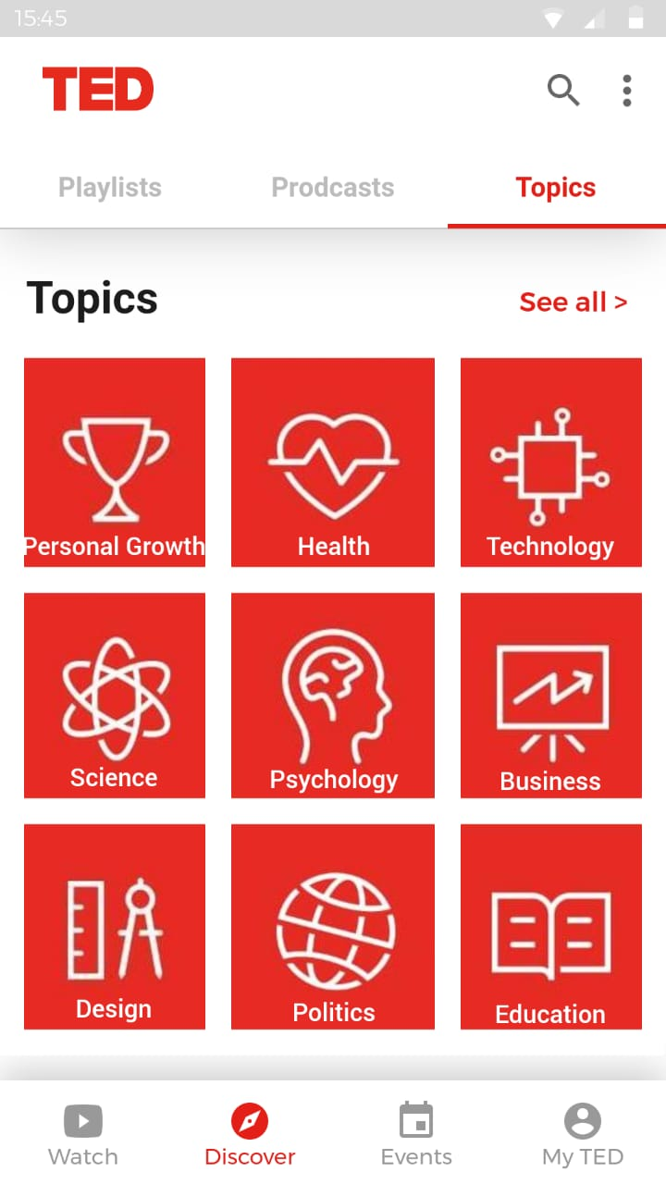

1. **Events Page.**

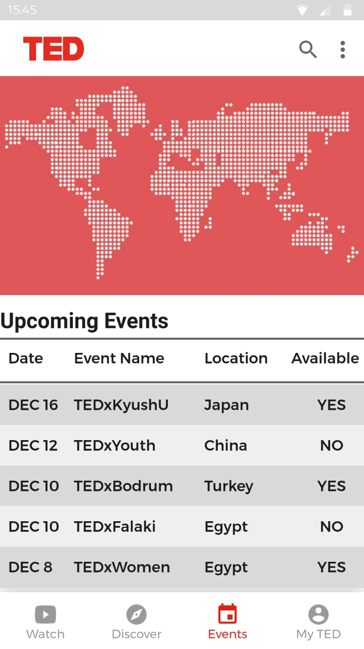

1. **My TED Page and the Log In Page**

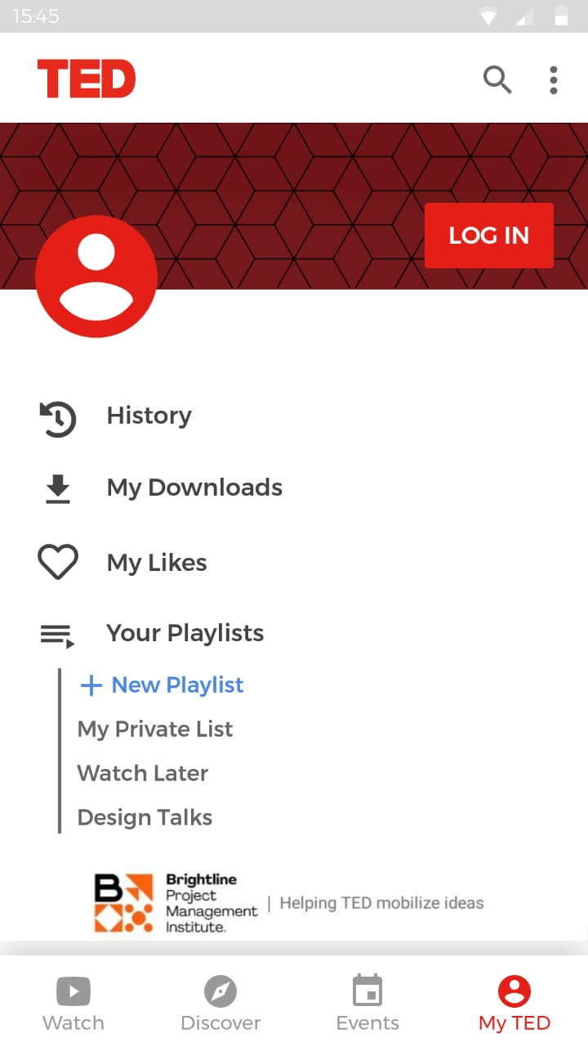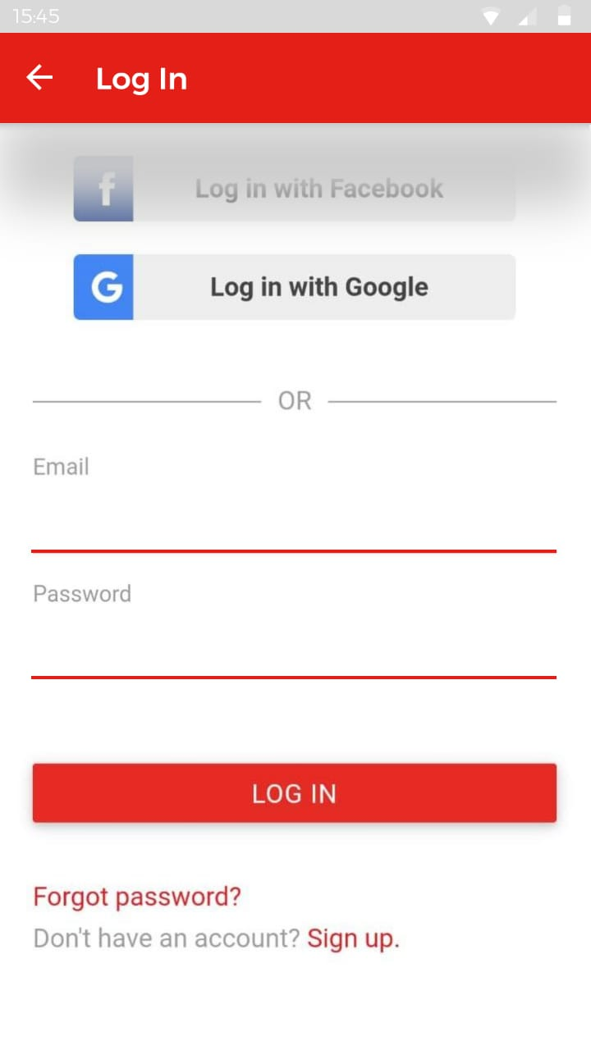

**4-Search Page**

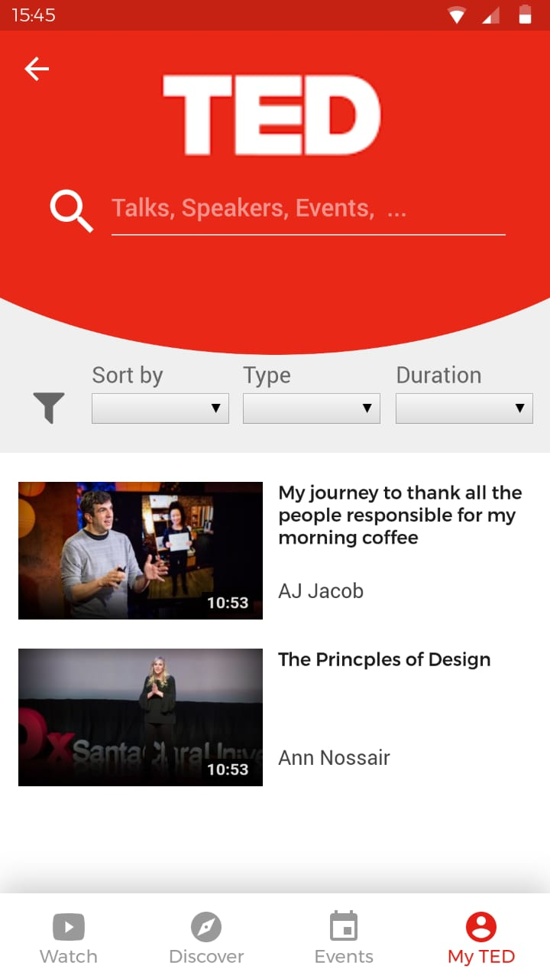

1. **The Video Player Page**

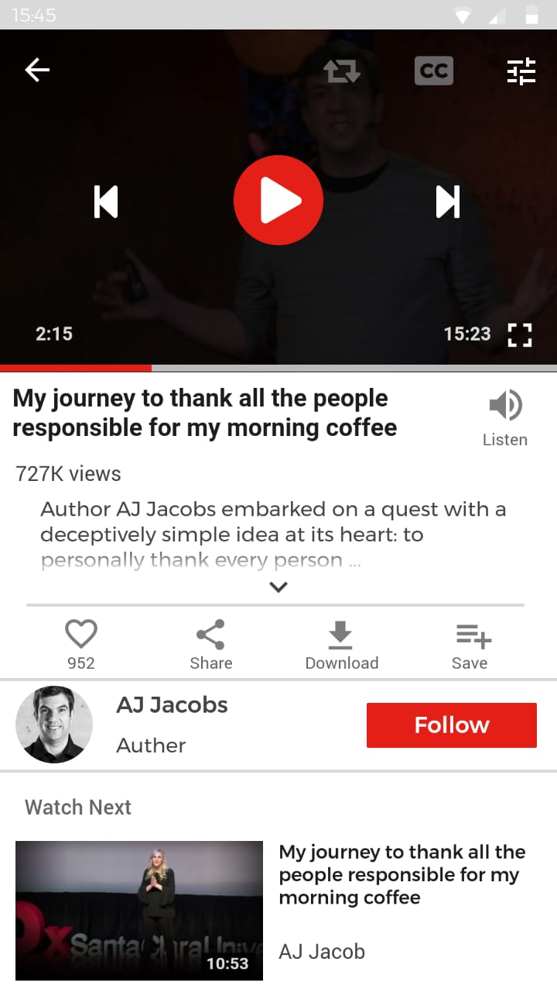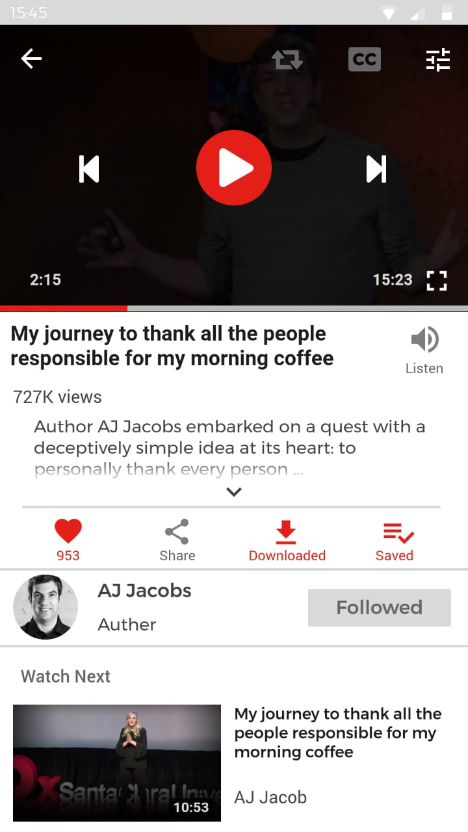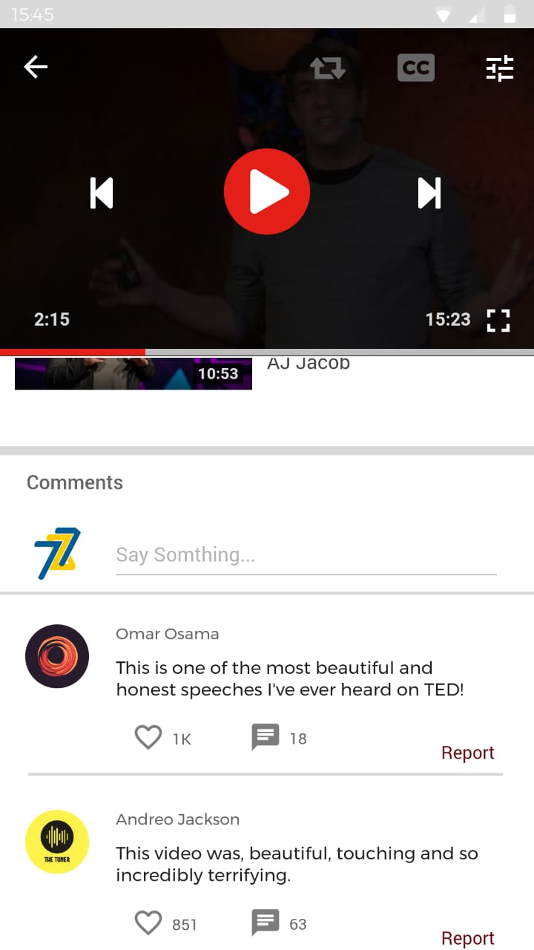

**Evaluation Phase**

**Evaluate according to Nielsen Rules:**

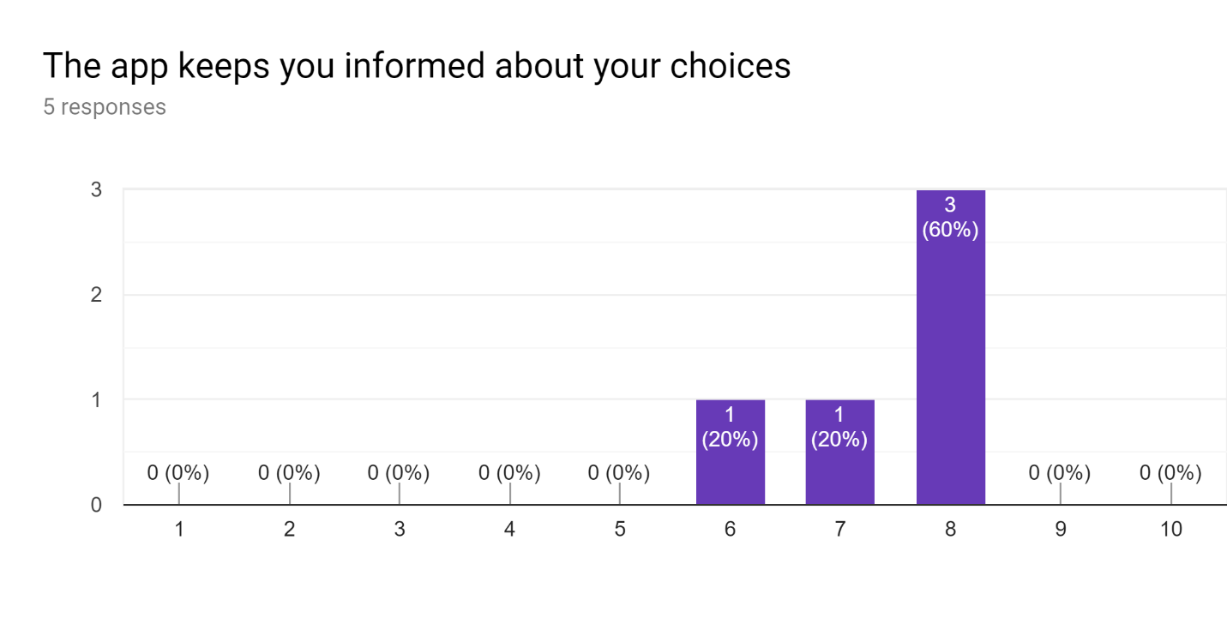

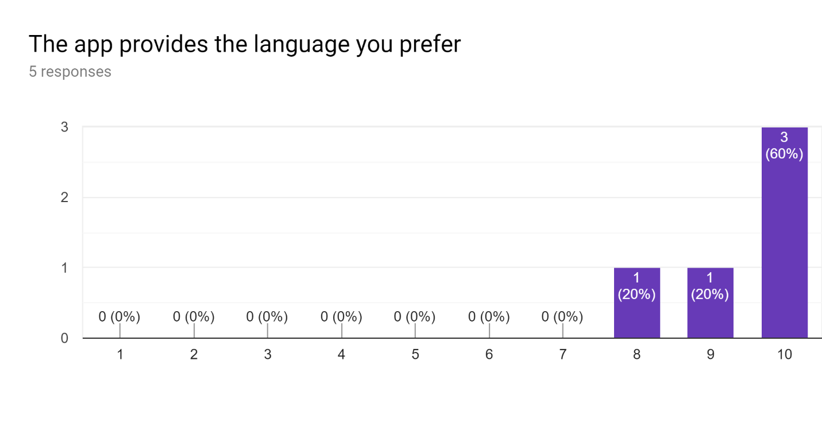

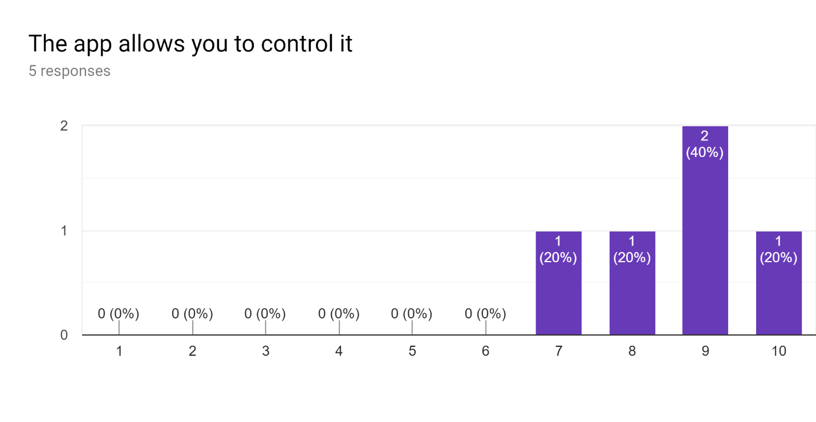

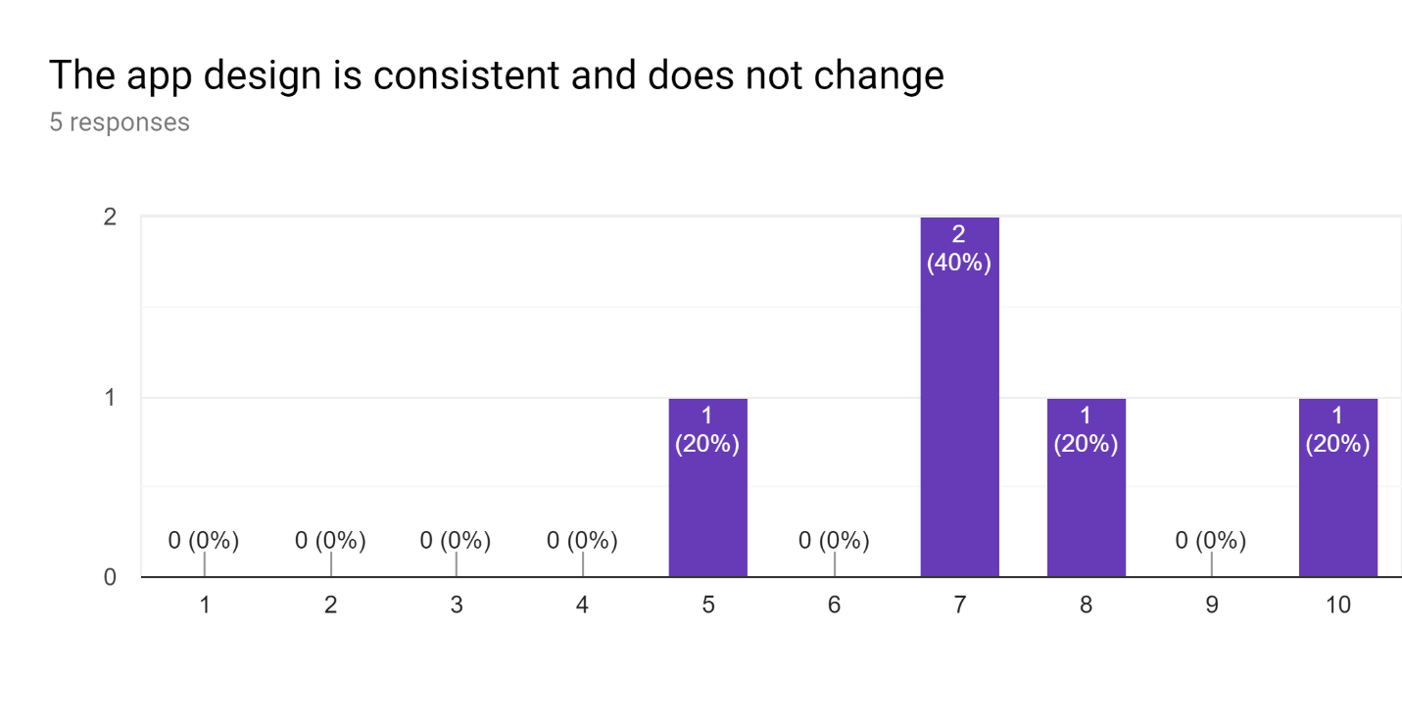

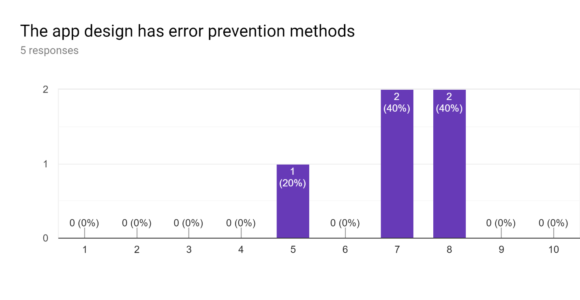

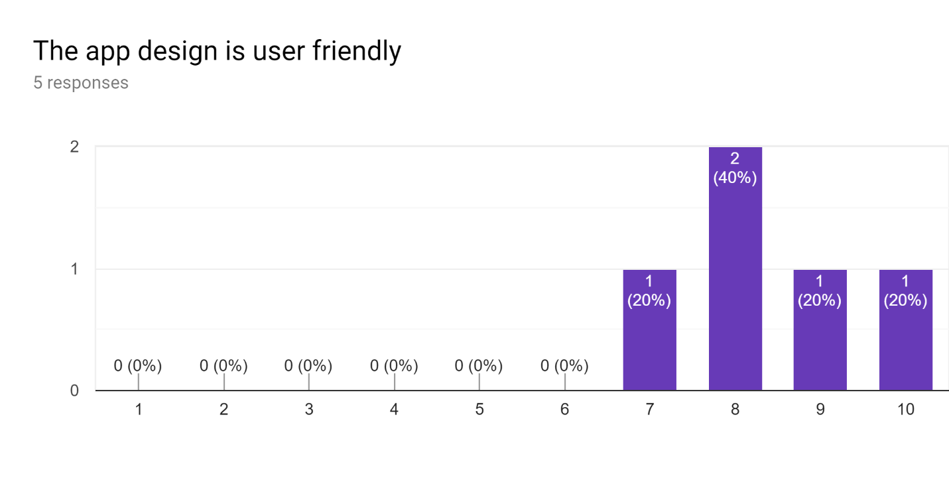

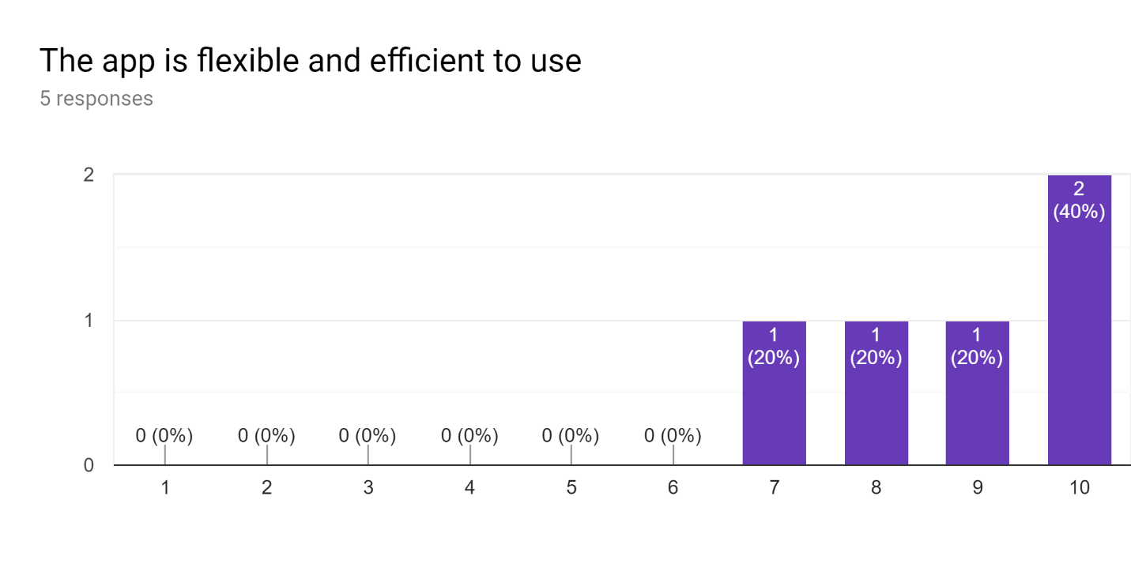

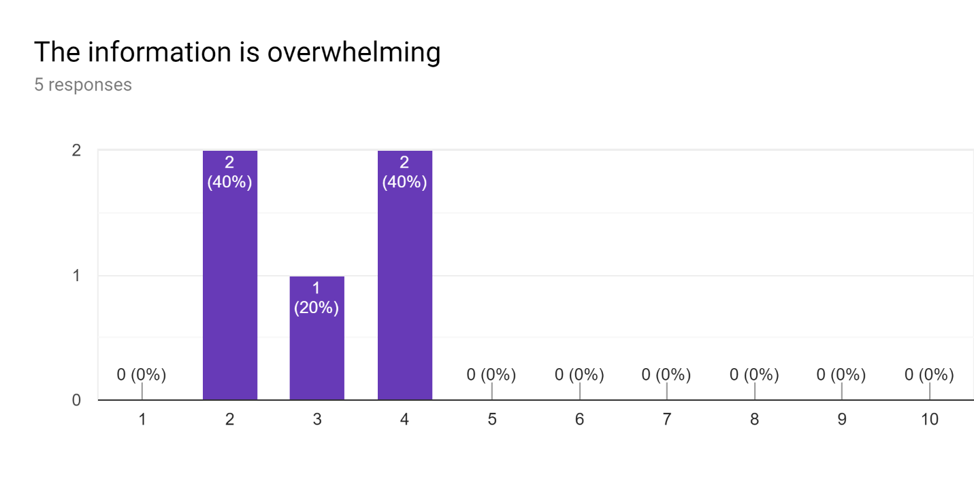

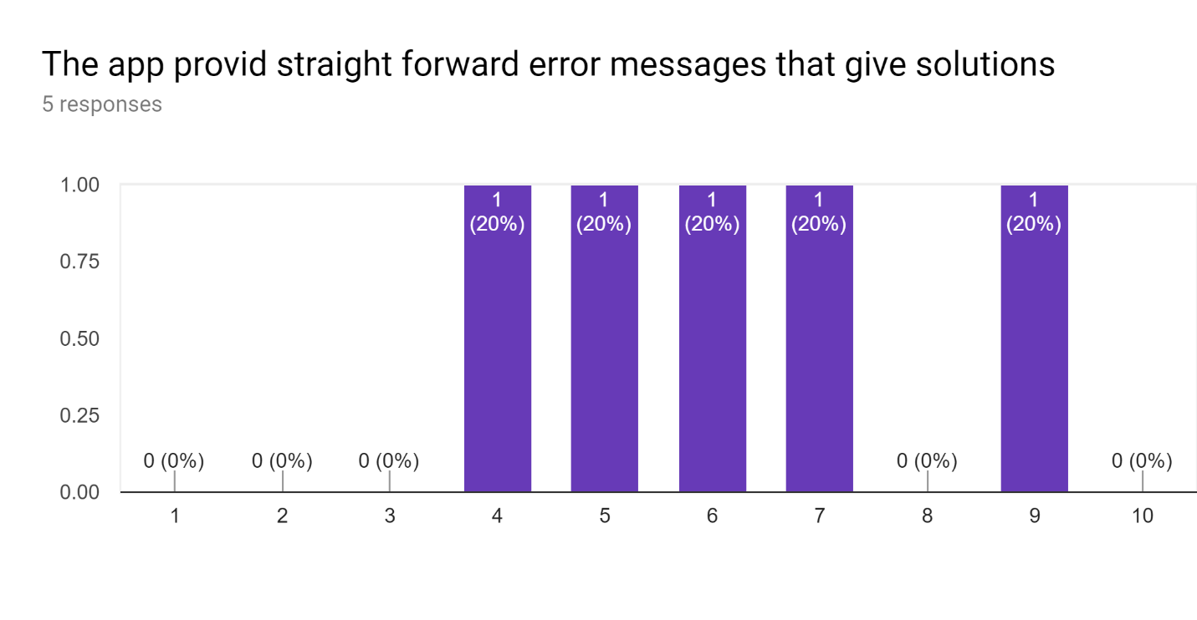

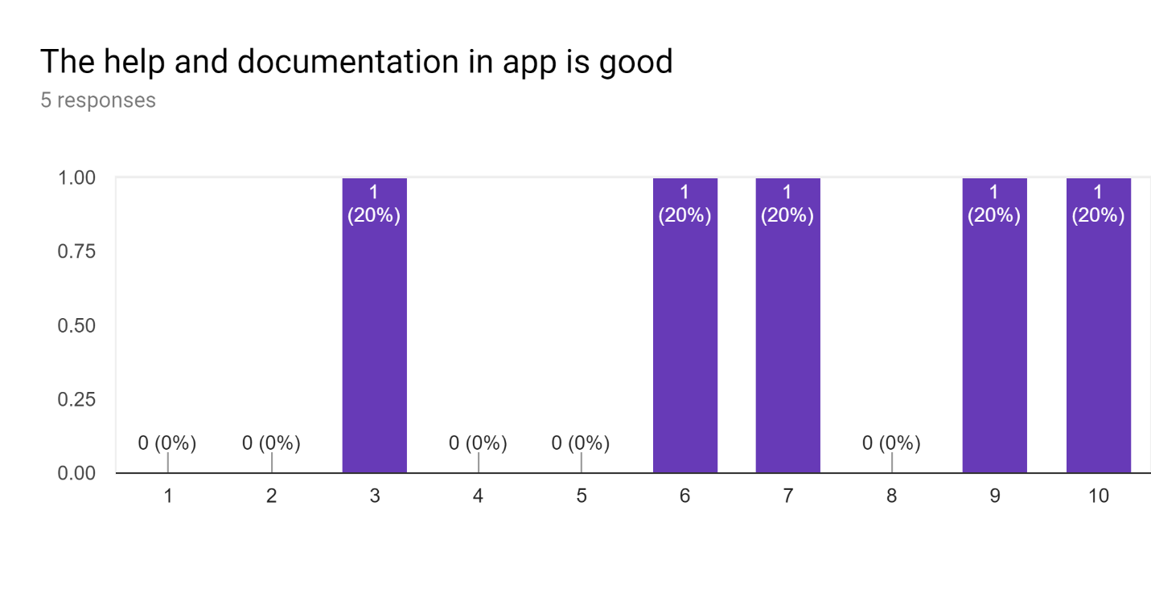

**Histogram:**

